 | Issue 14  Epsom & Ewell F.C.  v  Wembley F.C.  Saturday, 14th January 2012
A belated Happy New Year to you all! For this afternoon’s League match, we welcome the players, officials and supporters of Wembley F.C., today's officials, and of course our own regular supporters to the Moatside.

These two teams are no strangers to each other and today is in fact our fiftieth meeting, having played each other for the first time back in 1957. Of all the clubs we have played in our history, Wembley are thirteenth on our “most played” list, which is quite an achievement for an opponent that are quite some geographical distance from us.

Vale Farm is a venue where we had a gap of 46 years between wins from 1962 until 2008. That said, we then won three in a row before slipping to defeat there last October by four goals to one. I felt we were very unlucky that day, and hopefully our players will be up for a bit of revenge.

Before Christmas we welcomed Cove but produced a poor showing in our 3-2 defeat, then made the very familiar journey to Merland Rise on the Tuesday Bank Holiday and redeemed ourselves a little bit with a 1-0 win. We then suffered our first postponement of the season when a downpour ensured that Moatside was unplayable for the visit of Raynes Park Vale, and last Saturday crashed out of the League Cup 4-1 at lowly Worcester Park to end our hopes of any Cup success for another year.

Who knows what the New Year will bring us? Personally, I am hopeful that we will have some positive news on a new ground to celebrate later in the year, but the cynical amongst you would say that I’ve been saying that for ages! However, this time one thing is different, and before the year is out we will have a very clear view of our future destiny after years of being left in limbo. We will of course advise more as soon as we know.

We travel to the Arena next Saturday for our third meeting this season with Croydon, and return here for the visit of Dorking two weeks today.

Enjoy the game!

Richard

Cover photo this week by Gemma Jarman

Jamie Cottee fires home our second goal
in the 2-3 home defeat to Cove

Cherry Red Records Combined Counties League
Premier Division Table
inc Tuesday 10th January | P | W | D | L | F | A | Pts | GD
Guildford City | 25 | 18 | 6 | 1 | 71 | 30 | 60 | +41
Windsor | 24 | 16 | 6 | 2 | 73 | 24 | 54 | +49
Egham Town | 24 | 15 | 4 | 5 | 67 | 41 | 49 | +26
Camberley Town | 25 | 14 | 4 | 7 | 70 | 38 | 46 | +32
Hanworth Villa | 22 | 14 | 3 | 5 | 58 | 29 | 42** | +29
Molesey | 23 | 13 | 3 | 7 | 59 | 34 | 42 | +25
Horley Town | 24 | 12 | 4 | 8 | 54 | 33 | 40 | +21
South Park | 23 | 11 | 4 | 8 | 38 | 31 | 37 | +7
Croydon | 26 | 9 | 6 | 11 | 41 | 39 | 33 | +2
Badshot Lea | 25 | 10 | 3 | 12 | 41 | 45 | 33 | -4
Sandhurst Town | 23 | 11 | 0 | 12 | 38 | 48 | 33 | -10
Ash United | 26 | 9 | 4 | 13 | 46 | 52 | 31 | -6
Dorking | 24 | 9 | 3 | 12 | 32 | 50 | 30 | -18
Epsom & Ewell | 23 | 8 | 5 | 10 | 39 | 45 | 29 | -6
Cove | 26 | 8 | 5 | 13 | 46 | 67 | 29 | -21
Wembley | 23 | 7 | 7 | 9 | 39 | 41 | 28 | -2
Colliers Wood United | 23 | 7 | 4 | 12 | 42 | 54 | 25 | -12
Raynes Park Vale | 23 | 7 | 3 | 13 | 34 | 63 | 24 | -29
Banstead Athletic | 26 | 6 | 5 | 15 | 31 | 70 | 23 | -39
Farnham Town | 23 | 5 | 6 | 12 | 28 | 48 | 21 | -20
Chessington & Hook | 24 | 6 | 3 | 15 | 34 | 65 | 21 | -31
Mole Valley SCR | 25 | 5 | 2 | 18 | 33 | 67 | 17 | -34

- ** Hanworth Villa - ineligible player v Croydon - 3 points deducted
Lucky Day? – 14th January
Played 12 - Won 4 Drawn 3 Lost 5 - F 21 A 18 - PPG 1.25 - Below Average
Club record against today’s opponents
Played 49 - Won 17 Drawn 14 Lost 18 - F 81 A 73 - PPG 1.33 - Average
Last visit
12th April 2011 - Lost 2-3 - Combined Counties League

Lyndon Buckwell
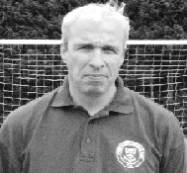
Hello everyone and welcome to this afternoon’s league game against Wembley.

Wembley like ourselves aren't enjoying the best of times at the moment, but I’m sure they fancy their chances against us this afternoon, so we need to be at our best if we are to get anything from the game.

I’d like to take this opportunity to apologise to all the club officials and supporters who came to Worcester Park last week hoping to see us progress into the next round of the League Cup. Instead you witnessed a half-hearted performance, which I can only describe as the most embarrassing 90 minutes of football I’ve had to sit through since becoming Epsom’s manager.

I’ve got to know most of you since I’ve been at the club and you’re an honest bunch whose only demand is to see the team give their all every time they go out and play. Sadly this hasn't happened as often as I would have liked, and as the Manager I have to take a lot of the blame.

The atmosphere in the squad is good and the players turn up whatever the weather for the training sessions, but I think our problems come in the games where it seems to me that every team we play against seem to work harder than us both with and without the ball. Hopefully we can start to put this right today with a good hard working performance.

Enjoy the game

Lyndon

Latest Results and Fixtures
Combined Counties League – Saturday 17th December
Ash United | 4-1 | Hanworth Villa
Badshot Lea | 0-1 | Croydon
Camberley Town | 1-1 | Chessington & Hook United
Dorking | 1-6 | Molesey
Epsom & Ewell | 2-3 | Cove
Mole Valley SCR | 0-4 | Horley Town
Wembley | 1-3 | South Park
Windsor | 10-0 | Raynes Park Vale
Combined Counties League – Tuesday 27th December
Banstead Athletic | 0-1 | Epsom & Ewell
Cove | 5-5 | Camberley Town
Croydon | 3-0 | Mole Valley SCR
Farnham Town | 0-3 | Ash United
Guildford City | 3-2 | Dorking
Hanworth Villa | 3-0 | Wembley
Molesey | 4-0 | Chessington & Hook United
Sandhurst Town | 3-2 | Badshot Lea
South Park | 2-1 | Horley Town
Windsor | 4-1 | Egham Town
Combined Counties League – Monday 2nd January
Ash United | 6-1 | Sandhurst Town
Badshot Lea | 3-2 | Cove
Camberley Town | 6-0 | Farnham Town
Chessington & Hook United | 3-1 | Croydon
Egham Town | 3-1 | Hanworth Villa
Horley Town | 3-5 | Guildford City
Wembley | 0-2 | Molesey
Combined Counties League – Wednesday 4th January
South Park | 0-2 | Mole Valley SCR
EL Records League Cup Second Round – Saturday 7th January
Worcester Park | 4-1 | Epsom & Ewell
Combined Counties League – Saturday 7th January
Banstead Athletic | 2-1 | Badshot Lea
Cove | 2-0 | Colliers Wood United
Croydon | 3-1 | Dorking
Farnham Town | 1-3 | Sandhurst Town
Hanworth Villa | 1-2 | Guildford City
Horley Town | 4-1 | Chessington & Hook United
Mole Valley SCR | 2-3 | Windsor
Molesey | 4-0 | Camberley Town
Raynes Park Vale | 2-0 | Ash United
Wembley | 1-2 | Egham Town
Surrey Senior Cup – Tuesday 10th January
Molesey | 0-2 | Corinthian Casuals
Ash United | 0-3 | Woking
South Park | 1-0 | Leatherhead
Combined Counties League – Tuesday 10th January
Banstead Athletic | 1-3 | Egham Town
Cove | 3-6 | Hanworth Villa
EL Records League Cup Third Round – Wednesday 11th January
Colliers Wood United | 2-1 | Dorking
Combined Counties League – Saturday 14th January
Ash United | V | Mole Valley SCR
Badshot Lea | V | Hanworth Villa
Camberley Town | V | Colliers Wood United
Chessington & Hook United | V | Banstead Athletic
Egham Town | V | Raynes Park Vale
Epsom & Ewell | V | Wembley
Guildford City | V | Horley Town
Sandhurst Town | V | Molesey
South Park | V | Croydon
Windsor | V | Farnham Town
Combined Counties League – Tuesday 17th January
Epsom & Ewell | V | Raynes Park Vale
Mole Valley SCR | V | Hanworth Villa
Sandhurst Town | V | Guildford City
Combined Counties League – Wednesday 18th January
Colliers Wood United | V | Farnham Town
F.A.Vase Fourth Round – Saturday 21st January
Whitley Bay | V | South Park
Combined Counties League – Saturday 21st January
Banstead Athletic | V | Guildford City
Colliers Wood United | V | Chessington & Hook United
Croydon | V | Epsom & Ewell
Dorking | V | Ash United
Farnham Town | V | Wembley
Hanworth Villa | V | Windsor
Horley Town | V | Camberley Town
Mole Valley SCR | V | Egham Town
Molesey | V | Badshot Lea
Raynes Park Vale | V | Sandhurst Town
EL Records League Cup Third Round – Tuesday 24th January
Badshot Lea | V | Sandhurst Town
Banstead Athletic | V | Worcester Park
Egham Town | V | Guernsey F.C.
Combined Counties League – Saturday 28th January
Ash United | V | Horley Town
Badshot Lea | V | Farnham Town
Chessington & Hook United | V | Mole Valley SCR
Croydon | V | Camberley Town
Egham Town | V | Cove
Epsom & Ewell | V | Dorking
Guildford City | V | Wembley
Raynes Park Vale | V | Banstead Athletic
Sandhurst Town | V | Colliers Wood United
South Park | V | Hanworth Villa
Windsor | V | Molesey

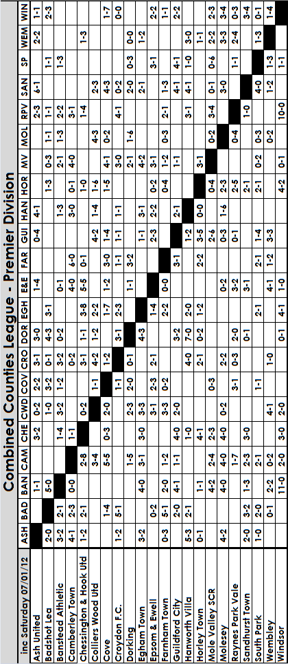

From behind the goal
Epsom & Ewell 2-3 Cove – Combined Counties League
Saturday 17th December 2011

The surprise of finding out that this game would be on gave us an unexpected but ideal opportunity to put right all the things that had gone wrong against Chessington & Hook the previous Saturday. Unfortunately, it was an opportunity wasted as we didn’t really turn up until the game was an hour old and the damage had been done by then.

Alex Rodrigues was away and his replacement Jamie Summers was still struggling with injury, so Paul West moved into the centre with Tom Siefers getting the start at right back. In midfield Carl Downs returned from injury and Nathan Ayling dropped to the bench.

Matt Smith fizzed a shot across the face of the goal after 11 minutes but the visitors looked quite dangerous going forward, and they took the lead in the 20th minute, when their right-winger crossed the ball over. An incoming striker missed it at the near post, but following up was a completely unmarked player who had an easy job of slotting the ball past Adrian Jones. If Jones was blameless for that one, he couldn’t escape some for the second goal that came just three minutes later, although why we needed to play a back pass on a bobbly Moatside pitch is beyond me. Jones scuffed the kick straight to an opposition player who lifted it back over him and into the net.

It was a nightmare scenario after letting in five goals the previous week and we were in real trouble. In fairness Jones redeemed himself almost immediately with a great save after a Cove striker was clean through when our defence parted again, and Matt Smith grazed the bar with a cross. Our only other chance of note was a move between Smith and Jamie Cottee that ended with the latter falling over and Smith appealing for a penalty that wasn’t there. He nearly got booked for his protestations, although if the referee was lenient then, he would at no time in the future apply any leniency at all, as he infuriated both sets of players, and probably his assistants too. One such case occurred just before half time when I could see quite clearly from the other end of the field that Cove had won a corner. The Assistant also pointed for a corner. He ignored the appeals, despite obviously having no clear view of the incident, and waited for the Cove players to berate him, pretty much as a team, before booking one of them. It was as if he was on a commission!

One other thing worth reporting is that a Cove player was stretchered off after 37 minutes, at which point the visitors had to use their third substitute, having already had two players off with injury. Still, with their tricky striker out of the way, surely we could fight back in the second half?

Well, not straight away unfortunately, by which time we had conceded a third goal. We lost the ball in midfield, but won it back on the edge of the box only to lose it again, and after 55 minutes we were three-nil down.

Antony Myers came on for Siefers and Smith dropped to the right back position with Alex McGregor moving from left to right to accommodate the new player. Immediately we appeared to have more balance and a dangerous cross from Myers to the near post was flicked goalwards by returning substitute Ross White, but the keeper pulled off a fine save.

After 62 minutes Cottee was bundled over and Smith tucked away the penalty confidently, and three minutes later, another Myers cross attracted both visiting central defenders who got in each other’s way and the loose ball fell to Cottee who drilled the ball into the far corner. Game on you might think, but for all our pressure we were unable to get another shot on target. Further good crosses from Myers were not reached, or we missed the target and paid for this with defeat. The referee still had time for a final word when harshly sending Jamie Hatfield off for violent conduct (I didn’t see a foul of any kind myself) and the issues he had caused with his handling of the game boiled over at the end and led to a scuffle between both sets of players.

Maybe had Mark Jarman not had to go off at half time following a clash of heads we might have rescued a point. It certainly looked for a while like we would, but ultimately some poor defensive work gave us too much to do, and while no one really played well, it was quite clear where most of the fault lay. Happy Christmas Cove!

From behind the goal
Banstead Athletic 0-1 Epsom & Ewell – Combined Counties League
Tuesday 27th December 2011

At an almost tropical Merland Rise, the Salts faced a tough challenge against their former landlords. We were low on confidence, following a run of three defeats and “that” draw at Chalky Lane and some of our own people were even talking of the possibility of Banstead’s first League win since October.

And as it turned out every bit as close as we had expected. The two sides were fairly even and ultimately it was only in the early part of the second half where we were clearly superior, that we scored the deciding goal.

The only changes to the line up from the defeat at Cove were for Alex Rodrigues to return to the heart of the defence at the expense of Anthony Panayi, while in midfield Sam Robinson was on holiday so Ali Dewar returned to the starting eleven. Tom Siefers moved from defence into midfield with Matt Smith taking over at right back instead.

This left Alex McGregor out on the right to accommodate Dewar on the left and his early cross was just a fraction too high for the leaping Mark Jarman who was unable to keep the ball down with his header after just eight minutes. However, a bright start was nearly cancelled out by an error in defence when Jamie Hatfield’s header didn’t reach Adrian Jones in goal, but as the Banstead striker intercepted and headed for goal his shot was blocked at the near post by Paul West.

Three bookings in five minutes then followed for the home side before they came really close to scoring. A shot was placed over Jones but the ball came back off our far post and was cleared away. We were beginning to look second best and frustration continued after Jarman had done really well to break through on goal, but from a wide angle he chose to lay the ball back to Ross White in the 35th minute but he dragged his shot badly wide. Five minutes later he was in action again when both he and the keeper went for a through ball just outside the penalty area. Jarman was there first but made no contact with the ball, only for the keeper to then clatter into him. The covering defenders made it an easy yellow card decision for the referee and Smith blazed the free kick over the bar.

We just had time before the whistle blew to collect two unnecessary bookings for West’s clumsy challenge and Smith’s attempts to argue the point, but whatever was said at half time had the desired effect. For a while anyway.

The second half was just under three minutes old when a superb defence splitting pass set White through and he delayed shooting until the keeper had committed himself, clipping the ball over him for a classy finish. This led to a period of play in which it seemed inevitable that we would score again. Dewar’s goal bound shot was blocked, while White was wide from another chance. In the 59th minute Jarman got down the left but with a simple square pass required he over hit the ball and White was unable to reach it with an open goal waiting if the pass had been better. Four minutes later we had an almost exact replica of this move except it was down the right, but again the pass from Jarman was too hard and White could only prod the ball into the side netting at the far post.

Dewar was booked for a clumsy challenge midway through the half as the home side started to raise their game. The returning James Moon replaced him shortly afterwards but it was defence that was required at this point and Rodrigues blocked a shot well before Moon himself cleared off the line. Jones was also in action making some fine saves including one in injury time that he got down to very smartly which saved us two points.

Right at the end a defensive howler from a home defender left substitute Jamie Cottee with a good sight of goal, but instead of taking his time, he shot early and the keeper pulled off a fine save, although, to be honest, a second goal would have flattered us.

From behind the goal
Worcester Park 4-1 Epsom & Ewell
EL Records Combined Counties League Cup Second Round
Saturday 7th January 2012

The Salts made their first trip to Worcester Park’s homely Green Lane ground for nearly fifty years and will be hoping they don’t have to visit for another fifty following a very disappointing 4-1 defeat. The signs were ominous when it was noted that we only had three substitutes on the bench. Jamie Hatfield was suspended, but many others were nowhere to be seen, while our opponents had four former Epsom & Ewell first team players in Nick Drew, Gary McLaughlin, Marc Muino and Darren Beale.

We nearly led through Jamie Cottee after just two minutes, when his shot was hooked off the line by a defender, but our own recent defensive fragility resurfaced after just nine minutes when a right wing shot was going wide but was tapped in at the far post by the unmarked Muino. Our back four had been reshuffled again with Antony Myers at left back and Matt Smith on the right with Paul West moved in to the centre alongside Alex Rodrigues, but to concede on the first occasion we were required to defend was no doubt as galling for Lyndon as it was for the large contingent of Epsom supporters.

The remainder of the first half was mostly but not completely in our favour as we tried to get back on level terms. Park looked vulnerable but we were unable to make any possession count, with our only real chance of the half coming from Mark Jarman who got a toe to Ali Dewar’s superb right wing low cross, but was unable to get quite enough on the ball and it just missed the far post in the 41st minute.

Adrian Jones made a good double save just after the restart, but we were deservedly back on terms after 54 minutes. Myers was allowed some time and space to get forward on the left and he cut to the bye-line before laying the ball back to Cottee who stroked the ball past the keeper. A minute later we nearly took the lead from an identical move with Alex McGregor the provider but Cottee’s shot was blocked. We were well on top and there was only one winner at this point, I stupidly remarked to others behind the goal.

What followed will go down as one of the worst half hours in our entire history as from a position of total dominance we conceded again and promptly imploded. 67 minutes were on the clock when Forbes cut in from the left and his low shot beat Jones who may have been unsighted as he looked a little slow in getting down to the shot.

Despite a strong wind in our favour the game turned in that instant, as all self-belief seemed to evaporate. It didn’t help that moments later we lost Carl Downs with a nasty looking knock on his ankle and not long later Jarman was also limping off after being challenged poorly out on the touchline and suffering from a heavy fall on what looked like his shoulder from where we were.

The two substitutes didn’t exactly cover themselves in glory either. Sam Robinson came on for Downs and shortly afterwards received what looked a harsh booking for a challenge on the keeper. I think the referee went with a player’s over-reaction here. However, there was no excuse as he slid in recklessly on the touchline after 82 minutes and left the referee with no choice but to issue a second yellow card. A few minutes later Ayling clumsily took out the home side’s left winger and conceded the penalty that made the score 4-1, having been carved apart moments earlier for the previous goal. Further bookings then followed as our team appeared to lose their composure, not for the first time this season.

At this club we totally support our Management team, and I believe that some of the players are really letting them down right now. They do not appear to know the difference between competition and aggression as on Saturday there was plenty of the latter, but very little of the former.

Club History - 14th January
Date | Day | Competition |  | Opponents |  | Scorers
14/01/28 | Sat | London League | H | Bostall Heath | 10-3 | Marlow (6), Watts (3), Parr
14/01/33 | Sat | Surrey Charity  Shield Semi-Final | A | Sutton United | 3-2 | Marlow (2), Rance
14/01/39 | Sat | London League | H | Dagenham Town | 0-1
14/01/50 | Sat | Corinthian League | A | Slough Town | 1-1 | Rooke
14/01/56 | Sat | Corinthian League | A | Maidstone United | 1-4 | Murphy
14/01/61 | Sat | Corinthian League | H | Leatherhead | 2-0 | Hawkins, Robinson
14/01/78 | Sat | Isthmian League 2 | H | Rainham Town | 0-1
14/01/89 | Sat | Isthmian League 2s | H | Whyteleafe | 1-1 | Perkins
14/01/92 | Tue | Isthmian League 3 | H | Thame United | 1-0 | Webster
14/01/97 | Tue | Associate Members Trophy 2 | A | Met Police | 0-1
14/01/03 | Tue | Isthmian League 1s | H | Banstead Athletic | 1-3 | Stevens
14/01/06 | Sat | Isthmian League 2 | H | Kingsbury Town | 1-1 | Heuston
Seasons in the Past
90 years ago – Epsom Juniors
14/01/22 | Sat | Sutton & District League Premier Div | A | Banstead | 2-2 | ??
80 years ago – Epsom Town
16/01/32 | Sat | Amateur Cup 2 | A | Wycombe Wanderers | 2-7 | Dunne, Marlow
70 years ago – Epsom Town (war time)
17/01/42 | Sat | South Eastern Combination | H | Tooting & Mitcham United | 4-2 | ??
60 years ago – Epsom F.C.
12/01/52 | Sat | Corinthian League | H | Maidenhead United | 3-1 | Goddard, Honey, Banham
50 years ago – Epsom & Ewell F.C.
13/01/62 | Sat | Surrey Senior Cup 1 | H | Dulwich Hamlet | 1-2 | Brown
40 years ago – Epsom & Ewell F.C.
15/01/72 | Sat | Athenian League 2 | A | Eastbourne Town | 2-0 | Wiles, Roots
30 years ago – Epsom & Ewell F.C.
16/01/82 | Sat | F.A. Trophy 3q 2rep | A | Gravesend & Northfleet | 1-0 | Tuite
20 years ago – Epsom & Ewell F.C.
14/01/92 | Tue | Isthmian League 3 | H | Thame United | 1-0 | Webster
10 years ago – Epsom & Ewell F.C.
12/01/02 | Sat | Isthmian League 3 | H | Abingdon Town | 3-1 | Freeborough, Huckle, Stevens

14th January – In Summary
90 years ago this week Epsom Juniors travelled to the League leaders and eventual Champions Banstead, and nearly came away with both points, but conceded a late equaliser “on the call of time” and were forced to settle for a 2-2 draw, despite playing much of the game with ten men, following an injury during the build up to our opening goal.

84 years ago today Reg Marlow set a club record for goals in a match when he scored six in a 10-3 romp over Bostall Heath in the London League. Fred Watts also got three with Jack Parr getting the other one. The record has since been equalled by Leslie Marlow, Tommy Tuite and Andy Boxall but has never been passed.

80 years ago this week 7,000 people flocked to Loakes Park, home of Wycombe Wanderers for their Amateur Cup tie with little Epsom Town. For the second year in a row we drew the holders, and as with the previous year’s game with Ilford we took the lead early, although were 5-1 down at half time, eventually losing 7-2. It was unfortunate that we were denied from playing our best side, as Billy Williams was classed as a “permit player” meaning that as a professional, he couldn’t enter the Amateur Cup. Also, Captain George Mackesy was suspended following his harsh sending off in the previous round. I think it would have been a much closer match.

79 years ago today it was Leslie Marlow’s turn to take the plaudits as the Blues won 3-2 at Sutton United in the Surrey Charity Shield Semi-Final. It was probably not seen as a massive achievement at the time as this was the fourth time we had beaten them that season, but it would be 75 years before we would ever win at Gander Green Lane again, on that memorable night in December 2008.

70 years ago this week Tooting & Mitcham were seen off 4-2 at West Street, with the first goal possibly being the quickest ever scored there. The description said that “the Epsom players ran up the field and scored without another player touching it”

60 years ago this week Maidenhead United were defeated 3-1 in a Corinthian League match at West Street after a goalless first half (see programme right). The goal scorers were Bill Goddard, Vic Honey and Cliff Banham, who I recently found out had played for Leytonstone in the 1947 Amateur Cup Final when they defeated Wimbledon 2-1. However, this was his only goal for us in thirteen appearances.

30 years ago this week we recorded a most impressive win in the F.A. Trophy when Alliance Premier League Gravesend & Northfleet were defeated in a second replay at Stonebridge Road. We had drawn 1-1 at West Street and 3-3 after extra time in the replay at Gravesend but a Tommy Tuite goal ensured their progress, although he also missed a penalty that day which would have made the game safer.

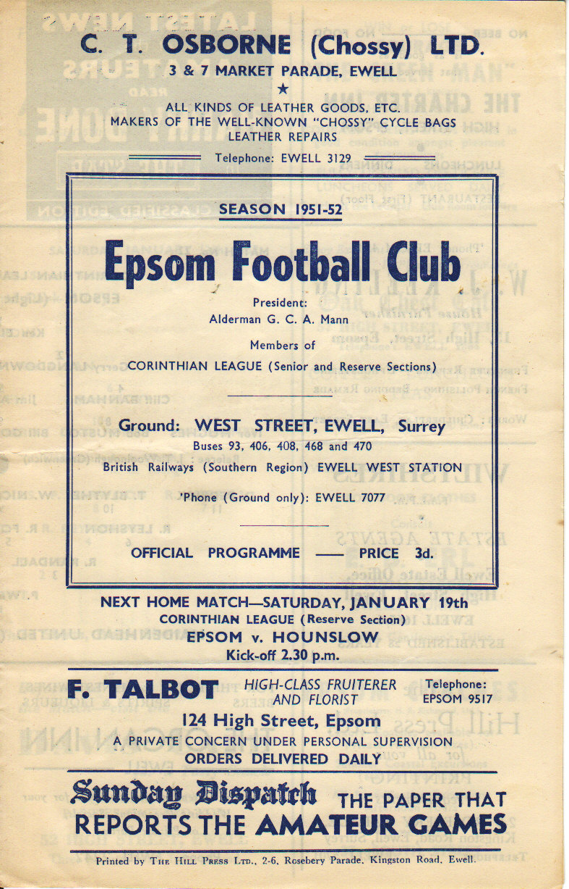
23 years ago today we hosted Whyteleafe in a match only interesting for the appearance of our former Secretary Dave Wilson running the line, due to an injury. It all looked bad after 89 minutes when Steve Hill scored, as he was by now playing for Whyteleafe, not us! However, we went straight up the other end and Brian Perkins equalised in the 90th minute for a point. It felt like we’d won though!

First Eleven Appearances - (max 30)
Name | Debut | 2011/12 |  |  |  | Career Totals
Name | Debut | App | Sub | Total | Goals | App | Sub | Total | Goals
AYLING Nathan | 15/11/08 | 12 | 4 | 16 | 1 | 12 | 11 | 23 | 1
BEDJ BEDJ Ramzi | 08/08/09 | 3 | 3 | 6 | 0 | 61 | 6 | 67 | 18
BURNS Robbie | 14/08/07 | 12 | 2 | 14 | 6 | 163 | 6 | 169 | 97
COLES Dan | 06/08/11 | 19 | 2 | 21 | 0 | 19 | 2 | 21 | 0
COTTEE Jamie | 26/11/11 | 4 | 3 | 7 | 4 | 4 | 7 | 6 | 4
DEWAR Ali | 29/10/11 | 8 | 2 | 10 | 0 | 8 | 2 | 10 | 0
DOWNS Carl | 17/09/11 | 13 | 3 | 16 | 0 | 13 | 3 | 16 | 0
FRANCIS Dave | 06/08/11 | 16 | 7 | 23 | 6 | 16 | 7 | 23 | 6
GROBLER Dre | 21/08/11 | 9 | 3 | 12 | 0 | 9 | 3 | 12 | 0
HARMSWORTH Matt | 10/09/11 | 0 | 3 | 3 | 1 | 0 | 3 | 3 | 1
HATFIELD Jamie | 11/11/06 | 14 | 3 | 17 | 0 | 146 | 10 | 156 | 5
HAYWARD Ben | 07/03/07 | 2 | 3 | 5 | 0 | 166 | 17 | 183 | 9
HOADLEY Harry | 27/08/11 | 1 | 0 | 1 | 0 | 1 | 0 | 1 | 0
JARMAN Mark | 08/08/09 | 25 | 2 | 27 | 12 | 57 | 19 | 76 | 29
JONES Adrian | 06/08/11 | 11 | 0 | 11 | 0 | 11 | 0 | 11 | 0
McGREGOR Alex | 08/08/09 | 23 | 5 | 28 | 2 | 85 | 31 | 116 | 9
MOON James | 16/08/11 | 3 | 2 | 5 | 0 | 3 | 2 | 5 | 0
MYERS Antony | 23/12/06 | 11 | 5 | 16 | 2 | 34 | 6 | 40 | 5
ORDUNO Inaki | 06/08/11 | 4 | 1 | 5 | 1 | 4 | 1 | 5 | 1
PANAYI Anthony | 14/11/10 | 18 | 3 | 21 | 0 | 39 | 3 | 42 | 1
RICHARDS Ayden | 09/08/11 | 1 | 6 | 7 | 0 | 1 | 6 | 7 | 0
ROBINSON Sam | 22/10/11 | 11 | 1 | 12 | 3 | 11 | 1 | 12 | 3
RODRIGUES Alex | 05/04/07 | 21 | 2 | 23 | 0 | 233 | 2 | 235 | 2
ROWE Steve | 27/08/11 | 5 | 1 | 6 | 0 | 5 | 1 | 6 | 0
SIEFERS Tom | 29/08/11 | 5 | 4 | 9 | 0 | 5 | 4 | 9 | 0
SMITH Matt | 08/08/09 | 21 | 3 | 24 | 6 | 75 | 23 | 98 | 8
SUMMERS Jamie | 06/08/11 | 22 | 1 | 23 | 3 | 22 | 1 | 23 | 3
WALSHE Sonny | 16/08/11 | 2 | 1 | 3 | 0 | 2 | 1 | 3 | 0
WEBBER Richard | 31/01/09 | 1 | 2 | 3 | 0 | 48 | 9 | 57 | 2
WEST Paul | 17/08/10 | 25 | 2 | 27 | 1 | 50 | 9 | 59 | 2
WHITE Ross | 15/03/11 | 1 | 1 | 2 | 1 | 9 | 2 | 11 | 3
WOODWARD Chris | 06/08/11 | 7 | 1 | 8 | 1 | 7 | 1 | 8 | 1

Evan Gregory
The events of the last few games have made me pause for thought about having some entrance music for our team as they take the field.

The first tune that came to mind was the theme to Steptoe and Son, although I felt that it was unkind of me to think that. However, I should really put a case for some piece of music that could be considered unique to us.


Now as I open a new metaphorical can of worms for us all to have our say I would like to suggest the idea that one member of the, well let’s call them the “Peofscola behindan se no sin” a rough translation into the old English for Boys behind the goal (please there is no Saxon word for goal, so I made a best approximation as the literal translation is the group behind the achievement) that our team could have two walk out tunes, one for when they have had a good game the week before, and one for when they failed to play up to expectations, for example the Hero’s Hallway from the film Bubba Ho-Tep (good), and Steptoe and Son (not so good). The logic behind this was that the players would try harder to win so they avoided hearing the bad tune again.

The walk out music should be a statement of intent, I really have to ask you to think what piece sends those shivers down your spine, pumps the blood that bit harder or steels your soul in a way that is hard to describe in a logical and ordered manner.

Music is a personal thing what one may consider a soul enriching; it could be a movie sound track or some piece of classical, or even a pop song from the back of your mind.

Here are some positive tunes.

1- The Hero’s Hallway (from the film Bubba Ho-Tep)
2- You better get ready to die (by Andrew W.K)
3-Throw away the books we're going into the streets (by Tokyo Kid Brother)
4-Highland Cathedral (traditional arrangement on the bagpipes)
5-Trollhammeren (by Finntroll)
6- God's goner cut you down (Johnny Cash)

For my negatives.

1- Send in the Clowns (Stephen Sondheim)
2- 19th Nervous Breakdown (Rolling Stones)
3- Theme tune from Steptoe and Son (aka Old Ned by Ron Grainer)
4- Hopeless (Breaking Benjamin album Dear Agony)
5- Despair (Anathema)
6- Avenge Me (Teknotokon)

I leave that to you good people to come up with some others.

(Ed note – Would anyone else like to have a go for positives or negatives? I’m sure we can come up with a few, the first negative that springs to mind was “Let ‘em In” by Paul McCartney and Wings, but I’m sure you can do better. There will be a huge prize for the winner ***)

*** Of course there won’t be a prize, what do you think we are, a charity!

Above and Below
Ryman League Division One South Table
inc Wednesday 11th January | P | W | D | L | F | A | Pts | GD
Bognor Regis Town | 24 | 16 | 6 | 2 | 64 | 21 | 54 | +43
Dulwich Hamlet | 23 | 16 | 4 | 3 | 47 | 16 | 52 | +31
Folkestone Invicta | 25 | 16 | 4 | 5 | 55 | 31 | 52 | +24
Whitehawk | 25 | 17 | 3 | 5 | 47 | 20 | 51 | +27
Maidstone United | 26 | 15 | 4 | 7 | 47 | 29 | 49 | +18
Worthing | 25 | 14 | 6 | 5 | 50 | 26 | 48 | +24
Chipstead | 24 | 11 | 6 | 7 | 39 | 28 | 39 | +11
Godalming Town | 22 | 11 | 5 | 6 | 35 | 31 | 38 | +4
Hythe Town | 25 | 11 | 4 | 10 | 41 | 45 | 37 | -4
Merstham | 25 | 9 | 7 | 9 | 39 | 45 | 34 | -6
Ramsgate | 24 | 9 | 5 | 10 | 35 | 42 | 32 | -7
Corinthian-Casuals | 25 | 7 | 10 | 8 | 33 | 39 | 31 | -6
Faversham Town | 24 | 8 | 6 | 10 | 28 | 36 | 30 | -8
Sittingbourne | 25 | 6 | 9 | 10 | 25 | 34 | 27 | -9
Crawley Down | 25 | 8 | 2 | 15 | 40 | 48 | 26 | -8
Walton Casuals | 25 | 7 | 5 | 13 | 34 | 48 | 26 | -14
Eastbourne Town | 23 | 6 | 7 | 10 | 30 | 39 | 25 | -9
Walton & Hersham | 25 | 6 | 5 | 14 | 24 | 31 | 23 | -7
Whitstable Town | 25 | 6 | 2 | 17 | 30 | 64 | 20 | -34
Burgess Hill Town | 25 | 4 | 7 | 14 | 27 | 52 | 19 | -25
Whyteleafe (-3) | 25 | 3 | 6 | 16 | 21 | 45 | 15* | -24
Croydon Athletic (-10) | 19 | 3 | 3 | 13 | 23 | 44 | 2* | -21

It looks like being the usual tight finish at the business end of the league above us. Bognor Regis and Whitehawk were right up there last season and they have been joined by Dulwich Hamlet who made a late run into the playoffs last season and could go one better this season. However, Folkestone Invicta and Maidstone United were two of the three relegated teams last season and so they are both equipped to go the distance. Worthing cannot be discounted either, but one of these good teams will miss out on the end of season fun, Only Chipstead and Godalming apart from the top six have a positive goal difference.

Croydon Athletic were the third of the relegated teams in 2010/11 and their financial problems are well documented. Docked ten points for their drop into administration it seems only a matter of time before they confirm their position in the bottom two, while Whyteleafe hover precariously along with Burgess Hill, who finished just outside the playoffs last season. I also note that the Swans are no longer the best club in Walton!

Will Athletic gain one of those Step Four reprieves, or will they actually become the first team to drop to Step Five in years? Maybe they’ll fold and reform, or maybe they won’t come back at all. It’s been an eventful decade at Mayfields and who knows what is next!

Above and Below
Combined Counties League Division One Table
inc Saturday 7th January | P | W | D | L | F | A | Pts | GD
Guernsey | 22 | 20 | 1 | 1 | 90 | 12 | 61 | +78
Bedfont Sports | 22 | 18 | 3 | 1 | 64 | 20 | 57 | +44
Warlingham | 24 | 14 | 5 | 5 | 52 | 30 | 47 | +22
Eversley | 23 | 14 | 3 | 6 | 62 | 33 | 45 | +29
Staines Lammas | 22 | 14 | 0 | 8 | 51 | 30 | 42 | +21
Hartley Wintney | 20 | 12 | 5 | 3 | 57 | 29 | 41 | +28
Spelthorne Sports | 21 | 12 | 3 | 6 | 44 | 27 | 39 | +17
Westfield | 23 | 12 | 2 | 9 | 42 | 43 | 38 | -1
Worcester Park | 22 | 10 | 3 | 9 | 54 | 45 | 33 | +9
Cobham | 21 | 9 | 2 | 10 | 39 | 49 | 29 | -10
Feltham | 23 | 8 | 0 | 15 | 33 | 46 | 24 | -13
Frimley Green | 22 | 7 | 3 | 12 | 32 | 59 | 24 | -27
Knaphill | 25 | 7 | 3 | 15 | 41 | 70 | 24 | -29
CB Hounslow United | 21 | 7 | 1 | 13 | 32 | 56 | 22 | -24
South Kilburn | 22 | 4 | 5 | 13 | 22 | 45 | 17 | -23
Farleigh Rovers | 21 | 3 | 3 | 15 | 27 | 56 | 12 | -29
Bookham | 22 | 2 | 4 | 16 | 22 | 56 | 10 | -34
Sheerwater | 22 | 2 | 2 | 18 | 24 | 82 | 8 | -58

Guernsey F.C. continue to head the table and with all due respect to Bedfont Sports, they don’t look as though they will be caught.

Although it may only be a runners-up spot they will earn, the “Sportsmen” will be more than happy, having missed out on promotion by a whisker last season.

Last time I reviewed this division it looked as though Hartley Wintney would wrap up the third promotion place, but as always with this division, nothing is ever as it seems, and although they remain in the box seat, any one of the teams down to Cobham in tenth could nip in here.

Teams at the bottom of our division will be looking more and more anxiously at this table as the season goes on, as it looks as though the top two would definitely fit the criteria, and there is every chance of a third doing so too, which would mean at least two down from our level, and if a team dropped from Step Four then it could well be that all three go down.

At the wrong end of the table it is disturbing to note that our friends at Bookham are having real trouble, and Farleigh’s win at South Kilburn this weekend has dropped them into the bottom two. Can they survive?

Steve Dyke
A Great game for the Neutrals

“You will have gathered that I was somewhat less than ecstatic at the final whistle last Saturday- to finish 5-5 from a 4-0 half time lead is hardly my ideal way of picking up an away point”

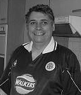
So began Jack Charlton’s programme notes in the Newcastle v West Ham programme from 29th September 1984. One of the advantages of a large programme collection is being able to pull something out for every occasion. Later in his column big Jack goes on to use and dismiss that well-worn cliché “it must have been a good game for the neutrals “.

Richard will no doubt have already done a piece on how rare the 5-5 draw is as a scoreline, and the QPR 5 Newcastle 5 from 22nd September 1984 is the last high profile one anyone can remember.

So who are these neutrals that take pleasure out of a high scoring game because I certainly wasn’t on Saturday? The Chessington supporters were delighted to cheer on an unlikely comeback, but in the sparse crowd that attended (and I had our small contingent in the minority) there were perhaps a handful of people who were truly neutral.

I have perhaps calmed down a little bit over the years in how I have taken defeat, as at my worst it can be a bit like the Monty Python lot’s Barnestoneworth United spoof … but I tell you, at ten to five I was truly gutted. Not my worst ever – I think that was an F.A. Trophy replay in the eighties at Grays at which we got in the lead and kept throwing the game away. I remember being on the train back with Tony Ashworth and neither of us spoke until Fenchurch Street. (Lost 3-2 in extra time – sickener – Ed!)

It’s not that I don’t ever watch games as a neutral, I often start out that way when I’m not watching Epsom but there’ll be something that happens in the game with the players or even in the crowd that will make my sympathies swing one way or another.

This season I’ve already written about the Burnley v Barnet game I was at when I really wanted Barnet to get some reward for their spirited performance, and I remember watching a Halifax v Rotherham game one Friday night when I lived in Yorkshire.

The Halifax fans I was standing among were only interested in booing their Manager and spouting mindless racist abuse at a couple of Rotherham players. I was quietly delighted when Rotherham won 4-0. I also had a very funny journey back to South Yorkshire with some of the Rotherham fans including a sociable couple of pints when we changed trains in Leeds. Any team that has the Chuckle Brothers behind them is all right by me.

So it is rare that I end any game in the state of pure idealised neutrality that I intended on starting out with. If I do it’s because the game probably hasn’t done anything to attract my attention.

There are two bad aspects to this 5-5 to my mind. I’ve written before about superstition and fan fatalism, from a superstition point of view it was a disaster. Richard may be able to correct me but I think the last time we led 4-1 at half time was the infamous Surrey Senior Cup tie against Walton and Hersham, so therefore 4-1 is a very dangerous lead to have at the break.

That night my fan fatalism kicked in as we knew that an early goal for them could get them going. Honestly though, at Chessington there was no fan fatalism occurring for me until it went 4-5. I knew then our goose was cooked but until then I just didn’t see it coming. We were 5-2 then 5-3 up against a team who were second bottom and we looked like we could get 8 or 10 and likely to score very time we went down the hill. This has now added a whole new range of situations I need to be cautious about – Doh!

And was it actually that good a game? Do a lot of goals actually automatically make it a good game? What would Alan Hansen have made of the rank bad defending on show? If he could get himself out of Morrisons, here’s what he might have made of it.

1-0 Epsom – linesman’s mistake with the ball about a yard over
1-1 Chessington’s first chance when a bad bobble let a guy through to score
1-2 A good goal - a long shot from Matt Smith
1-3 A long punt over the top undoes the woeful Chessy defence
1-4 Deflection
2-4 A good finish from the Chessington player
2-5 A well constructed goal for Matt Smith
3-5 / 4-5 / 5-5 Collective panic

Therefore the good goals only would have amounted to a 2-1 win for Epsom …. As a non-neutral, unbiased supporter I think I would have preferred that.

2nd XI Fixtures / Results - 2011/12
All HOME games to be played at Grand Drive, home of Raynes Park Vale F.C.
1 | 22/08/11 | Mon | MOLESEY | SL | 2-3 | Matthews, Hughes
2 | 27/08/11 | Sat | Thamesmead Town | SL | 1-1 | Hughes
3 | 03/09/11 | Sat | Hanworth Villa | SLC 1-1 | 3-4 | Williams, Harmsworth, Okolie
4 | 17/09/11 | Sat | South Park | SL | 2-2 | Adewale, Hagan
5 | 19/09/11 | Mon | CHESSINGTON & HOOK | SL | 4-1 | Alsanawi (2),  Gough, Pangisban
6 | 24/09/11 | Sat | Oakwood | SL | 5-0 | Binns (2), Alsanawi, Matthews, Hughes (pen)
7 | 26/09/11 | Mon | Redhill | SL | 4-4 | Adewale, England (pen), Martin, Gough
8 | 03/10/11 | Mon | LINGFIELD | SL | 2-1 | Hughes, Matthews
9 | 08/10/11 | Sat | Corinthian | SL | 6-1 | Hughes (2, 1 pen), Tilly, Flack, Dewar, Bassaka
10 | 12/10/11 | Wed | Mole Valley SCR | SL | 4-0 | Williams, Tilly, Hughes, Allan
11 | 24/10/11 | Mon | WALTON & HERSHAM | SL | 3-0 | Dewar (2), Richards
12 | 05/11/11 | Sat | Crowborough Athletic | SL | 4-2 | Hughes, Williams, Francis, Matthews (pen)
13 | 14/11/11 | Mon | COBHAM | SL | 5-1 | Francis (2), Stephens, Hughes, Alsanawi
14 | 19/11/11 | Sat | Horley Town | SL | 2-1 | England, Alsanawi
15 | 28/11/11 | Mon | HANWORTH VILLA | SLC 1-2 | 2-1 | Hughes (pen), Matheson
16 | 03/12/11 | Sat | Chessington & Hook | SL | 1-0 | Matthews
17 | 28/01/12 | Sat | Walton & Hersham | SL
SL - Suburban League SLC - Suburban League Cup

Suburban League Southern Division Table
inc Tuesday 10th January | P | W | D | L | F | A | Pts | GD
Walton & Hersham | 15 | 14 | 0 | 1 | 49 | 18 | 42 | +31
Epsom & Ewell | 14 | 10 | 3 | 1 | 45 | 17 | 33 | +28
Thamesmead Town | 14 | 9 | 3 | 2 | 47 | 23 | 30 | +24
Corinthian | 15 | 7 | 3 | 5 | 34 | 33 | 24 | +1
South Park | 15 | 7 | 2 | 6 | 45 | 40 | 23 | +5
Molesey | 12 | 5 | 5 | 2 | 28 | 24 | 20 | +4
Redhill | 16 | 5 | 3 | 8 | 31 | 40 | 18 | -9
Crowborough Athletic | 12 | 4 | 4 | 4 | 32 | 29 | 16 | +3
Oakwood | 14 | 5 | 1 | 8 | 29 | 43 | 16 | -14
Lingfield | 15 | 4 | 3 | 8 | 32 | 47 | 15 | -15
Mole Valley SCR | 16 | 4 | 1 | 11 | 25 | 50 | 13 | -25
Chessington & Hook United | 13 | 3 | 2 | 8 | 24 | 26 | 11 | -2
Cobham | 14 | 3 | 2 | 9 | 29 | 43 | 11 | -14
Horley Town | 13 | 2 | 2 | 9 | 18 | 35 | 8 | -17

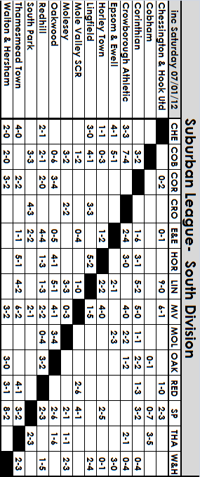

Reserve Team Appearances - (max 16)
Name | Debut | App | Sub | Total | Goals
Kris Adewale | 18/09/10 | 2 | 0 | 2 | 2
Chris Allen | 31/01/11 | 9 | 0 | 9 | 1
Ahmid Alsanawi | 03/09/11 | 5 | 4 | 9 | 5
John Antonio | 22/08/11 | 0 | 5 | 5 | 0
Nathan Ayling | 26/11/08 | 1 | 0 | 1 | 0
Luke Barnard | 05/11/11 | 0 | 2 | 2 | 0
Cody Best | 27/08/11 | 1 | 0 | 1 | 0
Kevin Bissaka | 08/10/11 | 1 | 1 | 2 | 1
Lee Binns | 03/10/09 | 0 | 1 | 1 | 2
Charlie Bryant | 19/11/11 | 1 | 0 | 1 | 0
Joe Butler | 27/08/11 | 6 | 3 | 9 | 0
Ali Dewar | 27/08/11 | 11 | 0 | 11 | 3
Ryan Edge | 19/11/11 | 1 | 0 | 1 | 0
Rem Edwards | 18/04/11 | 0 | 1 | 1 | 0
Sam England | 22/08/11 | 9 | 2 | 11 | 2
Jack Farley | 27/08/11 | 1 | 2 | 3 | 0
Dan Fell | 22/08/11 | 3 | 0 | 3 | 0
J Flack | 22/08/11 | 10 | 3 | 13 | 1
Aaron France | 14/11/11 | 1 | 0 | 1 | 0
Dave Francis | 05/11/11 | 2 | 0 | 2 | 3
Paul Gough | 22/08/11 | 10 | 2 | 12 | 2
Kofi Hagan | 17/09/11 | 1 | 2 | 3 | 1
Luke Harmsworth | 27/08/11 | 1 | 0 | 1 | 0
Matt Harmsworth | 22/08/11 | 3 | 0 | 3 | 1
Jamie Hatfield | 21/02/09 | 1 | 0 | 1 | 0
George Howland | 07/03/11 | 0 | 1 | 1 | 0
Micky Hughes | 22/08/11 | 12 | 1 | 13 | 10
Zack Jackhart | 03/09/11 | 4 | 3 | 7 | 0
Dan Kelton | 17/09/11 | 8 | 0 | 8 | 0
Jacub Malczuk | 08/10/11 | 1 | 0 | 1 | 0
Vic Martin | 22/08/11 | 2 | 2 | 4 | 1
Kyle Matheson | 13/11/10 | 0 | 1 | 1 | 1
Lewis Matthews | 22/08/11 | 13 | 0 | 13 | 5
Archie Okolie | 28/08/10 | 3 | 0 | 3 | 1
Anthony Panayi | 26/09/09 | 1 | 0 | 1 | 0
Godfrey Pangisban | 19/09/11 | 1 | 1 | 2 | 1
Damion Parris | 22/08/11 | 1 | 0 | 1 | 0
Ayden Richards | 12/03/11 | 0 | 2 | 2 | 1
Steve Rowe | 24/10/11 | 1 | 0 | 1 | 0
Leslie Sampson | 19/09/11 | 0 | 3 | 3 | 0
Tom Siefers | 22/08/11 | 6 | 0 | 6 | 0
Martin Smith | 03/12/11 | 0 | 1 | 1 | 0
Andy Smithers | 03/09/11 | 1 | 0 | 1 | 0
Aaron Stephens | 27/08/11 | 8 | 0 | 8 | 1
Alex Tilly | 03/09/11 | 7 | 0 | 7 | 2
Alfie Tuck | 03/09/11 | 1 | 0 | 1 | 0
Corbin Turner | 19/11/11 | 1 | 0 | 1 | 0
Sonny Walshe | 12/10/11 | 5 | 0 | 5 | 0
Richard Withers | 07/04/11 | 0 | 1 | 1 | 0
Aaron Williams | 09/02/08 | 10 | 2 | 12 | 3

Wembley F.C. – History
Wembley FC was formed in 1946 following an amalgamation of various junior clubs, predominantly Sudbury Ratepayers Association and Sudbury Rangers. Nicknamed the ‘Lions’ they found a home at Vale Farm and have remained there ever since, developing a roped-off pitch into a respectable non-League football ground.
Entry was immediately made into the Middlesex League, where they won the championship in 1947-48. A further season was spent in this league before the Club progressed to the Spartan League in 1949-50. Here they stayed for two years, clinching the Western Division title in 1950-51 as a result of which they became founder members of the Delphian League.

In season 1955-56 they finished runners-up in the Delphian League and were invited to join the Corinthian League. Following a quiet period the Club moved to the Athenian League (1963-64), which had absorbed both the Corinthian and Delphian League to create three divisions. The Lions remained in Division One until 1967-68 when they won promotion.

To anticipate further progress floodlights were installed, a new clubhouse and dressing-room complex were built until eventually admission to the expanding Isthmian League was granted in 1975. However, the closest they came to promotion to the Premier Division was in 1985-86. After completing their fixtures, Wembley headed the table only to miss out on promotion by two points when both St. Albans City and Bromley won their respective games in hand.

In 1980-81 they reached the First Round Proper of the FA Cup for the one and only time, losing 0-3 to Enfield at Southbury Road. The Middlesex Charity Cup was won outright for the first time in 1982-83, while the Middlesex Senior Cup was also clinched for the first time a season later with a dramatic 5-1 win over Hendon. In 1986-87 Wembley won the coveted Middlesex Cup double with final wins over Hayes in the Senior Cup and Feltham in the Charity Cup, a feat nearly repeated the following season. Several unprofitable years have followed and a fire at Vale Farm during the summer of 1992 almost ended Wembley’s existence. Fortunately, thanks to some splendid off-the-field work new facilities were quickly erected and the Club survived.

As a result of the restructuring of the Leagues constitution Wembley gained a first division (North) berth in season 2002-03. But they were unable to maintain their place and were demoted into the second division at the end of that season. Due to the disbanding of Division Two at the end of the 2005/06 season, where they have remained since, but were runners-up in last season’s EL Records Cup, being edged out by Sandhurst Town.

To Tweet or not to Tweet, that is the question!
Follow us on Twitter

Remember that you can follow us on Twitter. Just go on to http://twitter.com/EEFCWebmaster#l Alternatively, go to twitter.com and search for eefcwebmaster or Epsom and Ewell FC. You can then "follow us" (if you have a Twitter account).


We currently have 169 followers including Surrey Mirror Sport and the Surrey Advertiser, plus a number of clubs from our Division. In addition Radio Marsden update their listeners on our progress on match days thanks to our goal updates service (see below).

Goal updates

Get Epsom & Ewell goal updates sent direct to your mobile phone by signing up to receive text messages from Twitter (if your mobile phone is compatible).

Alan Carter and Richard Lambert are providing a First Team live score update service whenever possible, meaning that texts will be sent to your mobile phone as the goals happen.

Go on, give it a go and join in the fun! Let's see if we can get our followers up to 200!

To receive alerts to your mobile phone

1. Log into, or set up, your Twitter account and register your mobile phone.
2. Click on “Home” in the top menu bar
3. Click on “Following” at the top of the right-hand column.
4. Click on EEFCWebmaster and you will see in the left-hand column, a mobile phone icon next to the “Following” box. Click on that and you will be set up to receive Epsom and Ewell FC “tweets”. On the facing page is an excerpt from our Twitter page.

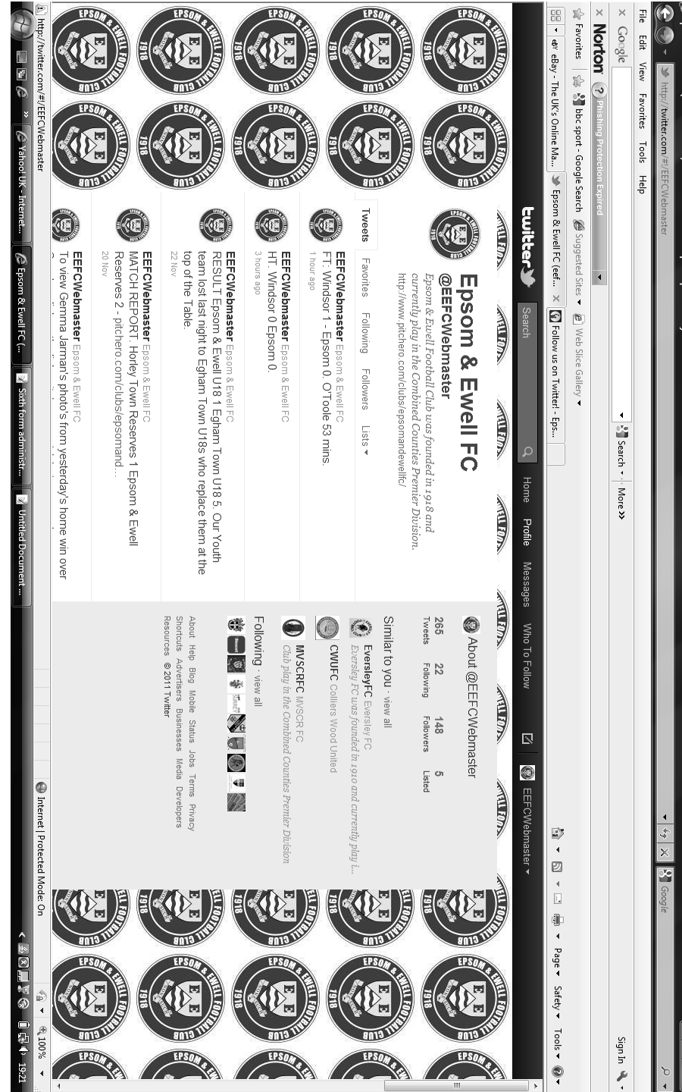


Alan Carter’s 9 at Half Time – Quiz 14
Al’s 9 at half time – Quiz 14

For those of you looking for something to do whilst you sip your half time “cuppa” and wait for the action to resume why not have a go at my 9 at half time quiz?

Even if you don’t know the answers at least you’ll end up with a juicy tit bit to tell your mates down the pub.

1. Who were England's full backs in the 1966 World Cup Final?

2. ESPN presenter Ray Stubbs was on the books of which English club?


3. Former Epsom and Ewell midfielder Paul Harding won the FA Trophy in 1988 with which current Essex Senior Football League side?

4. There are 2 current football league teams with an X in their name. Name one?

5. What do the following shirts have in common: West Ham’s No. 6, Man City’s No. 23 and Chelsea’s No. 25?

6. Where was the 1962 World Cup held?


7. How is the song “Offside” by Barry Stroller better known?

8. Epsom and Ewell finished 10th in the CCL Premier Division last season. How many points did we win?

9. Which current Combined Counties Premier League side play at Bottom Meadow?
Answers on page 51 – I got 6 –Ed!

This page for appearances spreadsheet (centre pages)

This page for appearances spreadsheet (centre pages)

Club Statistical History
Full Club Historical Record (up to date):

League: Played: 2,658, Won: 1,067, Drawn: 509, Lost: 1,076, Abandoned: 6
For: 4,848, Against: 4,766, Goal Difference: plus 82

Other: Played: 1,054, Won: 501, Drawn: 120, Lost: 432, Abandoned: 1
For: 2,302, Against: 1,970, Goal Difference: plus 332

Total: Played 3,712, Won: 1,568, Drawn: 629, Lost: 1,508, Abandoned: 7
For: 7,150, Against: 6,736, Goal Difference: plus 417

First Senior Match: 30th August 1924.
Lost 1-3 v Dorking at our home ground at the time of Horton Hospital Grounds.

First Match Programme Issued: 15th September 1923 v West Norwood Reserves.

Number of Grounds: Five.
Alexandra Recreation Ground 1918-1922, Horton Hospital Grounds 1922-1925,
West Street 1925-1993, Merland Rise 1993-2010, Moatside 2010 - present.

Record Win: 12th October 1935.
13-1 v Reigate Priory at West Street in the Amateur Cup.

Record Defeat: 14th February 1948.
14-0 at Chelmsford City Reserves in the London League.

Longest Serving Manager: 1) Adrian Hill 1982-1985 and 1990-2003
2) Pat O’Connell 1973-1982
3) Lyndon Buckwell 2006-present
4) Ricky Kidd 1986-1990

Record Appearances: 1) Graham Morris 658 1990-2004
2) Nigel Bennett 630 1989-2005
3) Tommy Tuite 582 1973-1987

Record Goalscorers: 1) Tommy Tuite 391 1973-1987
2) Reg Marlow 254 1924-1936
3) Jimmy Jones 148 1933-1945

Most Appearances in a season: Tony Coombe and Tommy Tuite - 59 in 1980/81.

Most goals in a season: Reg Marlow - 65 (at least) in 39 appearances in 1926/27

Senior League Titles: 6 - 1925/26 Surrey Senior League - 1926/27 Surrey Senior League - 1927/28 London League - 1939/40 Surrey Combination (war time emergency League) - 1974/75 Surrey Senior League - 1977/78 Isthmian League Division Two

Club Record against Wembley - Breakdown:
Competition | Played | W - D - L | F - A
Corinthian League | 14 | 7-3-4 | 33-19
Athenian League | 4 | 2-1-1 | 7-8
Isthmian League 1 | 14 | 2-9-3 | 12-12
Isthmian League 2 | 4 | 1-0-3 | 5-8
Combined Counties League | 11 | 4-1-6 | 20-23
EL Records League Cup | 1 | 1-0-0 | 3-0
F.A.Cup | 1 | 0-0-1 | 1-3

Our Website
Our website http://www.pitchero.com/clubs/epsomandewellfc/ is still going strong, and if you are a regular visitor to it, you will see many updates.

In our current position with a lack of a decent local paper in the Epsom area, the website is the only way to communicate with Epsom supporters who are not at the games.

If you are a supporter, please pass the address on to anyone you know that has ever expressed an interest in the club, especially those who don’t visit any more. You never know, some of them might be inspired to come along too, and bring their friends etc.

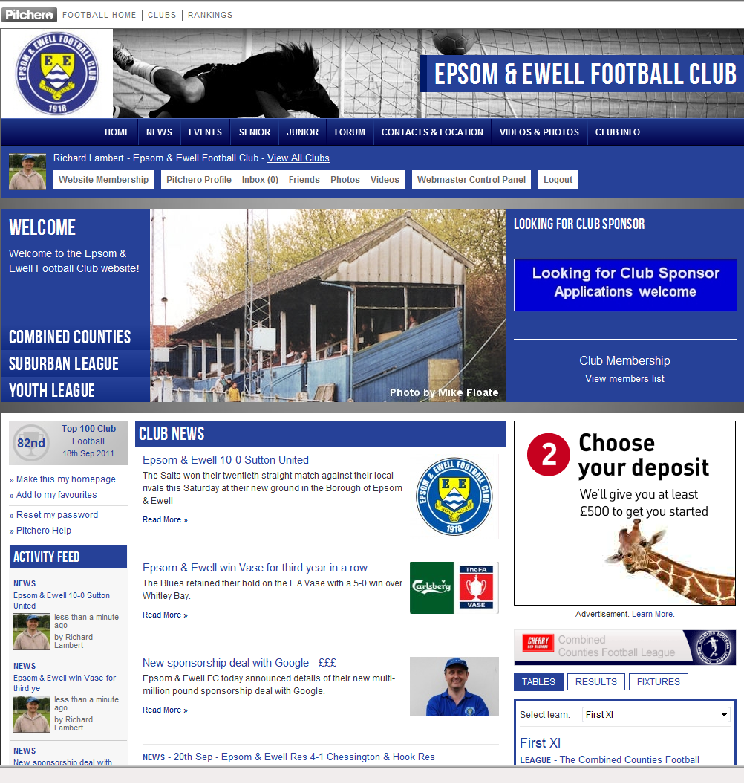

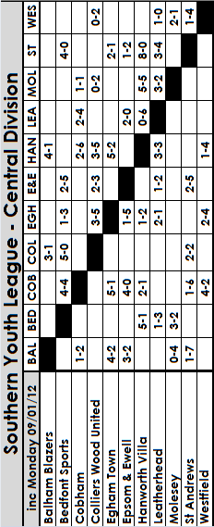

Youth Team Fixtures / Results 2011/12
1 | 05/09/11 | Thur | ST ANDREWS | SYL | 1-2 | Matheson
2 | 08/09/11 | Mon | Horsham | FAYC  PR | 2-1 | Smith (pen), Matheson
3 | 12/09/11 | Mon | BALHAM BLAZERS | SYL | 3-2 | Matheson, Smith (pen), Nadesan
4 | 26/09/11 | Mon | COBHAM | SYL | 4-0 | Jones, Matheson, Nadesan, Boyden
5 | 29/09/11 | Thur | Colliers Wood United | SYL | 3-2 | Matheson, Boyden, Bough
6 | 05/10/11 | Wed | Lancing | FAYC  2q | 9-0 | Smith (2, 1 pen), Bryant, Nadesan, Best, Jones, Matheson, Nevin (2)
7 | 10/10/11 | Mon | Egham Town | SMFC 1 | 0-3
8 | 17/10/11 | Mon | EBBSFLEET UNITED | FAYC 3q | 2-3+ | Jones, Smith
9 | 24/10/11 | Mon | Guildford City | SYLC 2 | 3-2 | Jones (2), Best
10 | 02/11/11 | Wed | Bedfont Sports | SYL | 5-2 | Jones (2), Nevin (2), Best
11 | 07/11/11 | Mon | LEATHERHEAD | SYL | 2-0 | Jones, Smith
12 | 10/11/11 | Thur | Crawley Down | SYLC 3 | 1-0 | Nevin
13 | 17/11/12 | Thur | St Andrews | SYL | 5-2 | Nevin (2), Achkar,  Jones, Smith
14 | 21/11/11 | Mon | EGHAM TOWN | SYL | 1-5 | Jones
15 | 01/12/11 | Thur | Leatherhead | SYL | 2-1 | Doyle, D.Smith
16 | 05/12/11 | Mon | EGHAM TOWN | SYLC  QF | 2-2+ | Jones (2)
Lost 4-3 on penalties
18 | 12/01/12 | Thur | Cobham | SYL
19 | 16/01/12 | Mon | COLLIERS WOOD UNITED | SYL
20 | 30/01/12 | Mon | HANWORTH VILLA | SYL
21 | 09/02/12 | Thur | Balham Blazers | SYL |  | @ Colliers Wood United
22 | 13/02/12 | Mon | WESTFIELD | SYL
23 | 22/02/12 | Wed | Molesey | SYL
24 | 27/02/12 | Mon | BEDFONT SPORTS | SYL
25 | 05/03/12 | Mon | Egham Town | SYL
 | tba |  | Hanworth Villa | SYL
 | tba |  | Westfield | SYL
 | tba |  | MOLESEY | SYL
 | tba |  | Farnham Town | GM 2
SYL - Southern Youth League FAYC - F.A. Youth Cup
GM – Grant McLellan Youth Cup
SYLC - Southern Youth League Cup SMFC - Surrey Midweek Floodlit Cup

Southern Youth League Cup
Third Round
Westfield | 2-3 | Oakwood
Lingfield | 3-2 | Molesey
Dorking | 3-2 | Balham Blazers
Godalming Town | 0-2 | Egham Town
Redhill | 2-1+ | Bedfont Sports
Eversley | 6-3 | St Andrews
Crawley Down | 0-1 | Epsom & Ewell
Crowborough Athletic | 0-1 | South Park
Quarter Finals
Redhill | 25/1 | Eversley
South Park | 26/1 | Lingfield
Dorking | 1-2 | Oakwood
Epsom & Ewell | 2-2+ | Egham Town
Lost 3-4 on penalties
Semi Finals
Oakwood | V | South Park / Lingfield
Egham Town | V | Redhill / Eversley

Southern Youth League Table
inc Monday 9th January | P | W | D | L | F | A | Pts | GD
Egham Town | 10 | 9 | 0 | 1 | 36 | 16 | 27 | +20
Epsom & Ewell | 9 | 7 | 0 | 2 | 26 | 16 | 21 | +10
Hanworth Villa | 12 | 6 | 2 | 4 | 42 | 33 | 20 | +9
Leatherhead | 10 | 5 | 1 | 4 | 24 | 19 | 16 | +5
Balham Blazers | 6 | 4 | 0 | 2 | 22 | 10 | 12 | +12
Molesey | 7 | 3 | 2 | 2 | 15 | 16 | 11 | -1
Bedfont Sports | 8 | 3 | 1 | 4 | 22 | 21 | 10 | +1
Westfield | 7 | 3 | 0 | 4 | 14 | 14 | 9 | 0
St. Andrews | 10 | 2 | 1 | 7 | 14 | 42 | 7 | -28
Cobham | 9 | 1 | 2 | 6 | 19 | 31 | 5 | -12
Colliers Wood Utd | 8 | 0 | 1 | 7 | 11 | 27 | 1 | -16

Youth Review
It’s been a quiet time for our Youth Team whose game at Hanworth Villa was postponed on 15th December. They were due to play at Cobham on Thursday, but the result is not known as this programme goes to press. Here’s hoping they can catch Egham Town up by the end of the season.

EL Records League Cup Draw
Second Round
Dorking | 5-3 | Farnham Town
Egham Town | 5-1 | Eversley
Colliers Wood United | 5-4+ | Cove
Farleigh Rovers | 3-2 | Sheerwater
Badshot Lea | 3-1 | Mole Valley SCR
Guernsey | 4-1 | Ash United
Windsor | 1-2 | Spelthorne Sports
Worcester Park | 4-1 | Epsom & Ewell
Cobham | 3-2 | Horley Town
Wembley | 0-0+ | South Kilburn
Wembley won 5-4 on penalties
South Park | 2-2+ | Sandhurst Town
Sandhurst Town won 4-3 on penalties
Banstead Athletic | 2-0 | Hartley Wintney
Guildford City | 2-1 | Hanworth Villa
Raynes Park Vale | 4-0 | Bedfont Sports
Feltham | 0-5 | CB Hounslow United
Staines Lammas | 3-2 | Warlingham
Third Round
Cobham | 3-2 | CB Hounslow United
Spelthorne Sports | 0-1 | Staines Lammas
Banstead Athletic | 24/1 | Worcester Park
Guildford City | 2-2+ | Wembley
Guildford City won 5-4 on penalties
Colliers Wood United | 2-1 | Dorking
Egham Town | 24/1 | Guernsey
Badshot Lea | 24/1 | Sandhurst Town
Raynes Park Vale | 3-0 | Farleigh Rovers
Quarter Finals
Staines Lammas | V | Egham Town / Guernsey
Cobham | V | Banstead Athletic / Worcester Park
Raynes Park Vale | V | Colliers Wood United
Guildford City | V | Badshot Lea / Sandhurst Town
Surrey Senior Cup draw
Third Round
Chipstead | 0-1 | Metropolitan Police
Walton Casuals | 1-2 | Ashford Town (Middx)
Sutton United | 17/1 | Godalming Town
South Park | 1-0 | Leatherhead
Ash United | 0-3 | Woking
Whyteleafe | 17/1 | Carshalton Athletic
Walton & Hersham | 17/1 | Lingfield
Corinthian Casuals | 18/1 | A.F.C. Wimbledon
Quarter Finals
South Park | V | Sutton United / Godalming Town
Whyteleafe / Carshalton Athletic | V | Metropolitan Police
Walton & Hersham / Lingfield | V | Corinthian Casuals / AFC Wimbledon
Woking | V | Ashford Town (Middx)

Every Opponent A-Z
Over the years we have played many, many different opponents. Exactly how many is a difficult question, as it all depends on your definition. Are Camberley & Yorktown different to Camberley Town, or are Epsom Town different to Epsom F.C. or Epsom & Ewell F.C.?

In my analysis I have classed them as the same team, and will work through them all from A to Z. Some we have played many times, whilst others we have met maybe just once or twice. Enjoy!

Farnborough North End: - Played 1 - W1 D0 L0 - F3 A2
Points per Game - 3.00 - Perfect

Farnborough North End were a Wessex League Division Two team when we met. We had received an exemption in the F.A. Vase to the first round and had fully expected to meet Egham at that stage. However, the North Enders won 2-1 at the Runnymede Stadium and so we hosted them at Merland Rise.

It was a very comfortable match as we eased into a two-goal lead, but two goals in a five minute spell, one of which was from nearly fifty yards out, forced us into extra time but Dale Marvell scored the winner as we dominated the final thirty minutes.

They joined the Combined Counties League the following season but problems with their ground and landlord ensured it was a brief stay, and despite being based in Hampshire, they now play in the Surrey Elite Intermediate League, although oddly they are back at their very same home, the Cody Sports Ground!

Farnborough Town: - Played 17 - W6 D2 L9 - F22 A26
Points per Game - 1.18 - Below Average

Farnborough Town were a very new club, only forming in the late sixties, and following some time in the Spartan League, they followed us up through the Surrey Senior League and into the Athenian League. When we first met them, we were in that League’s top flight, while they were in Division Two.

We were drawn together in the Athenian League Cup Semi-Final on 25th April 1977 at Cherrywood Road, a venue where they had not lost in 86 home matches, but we were quite good ourselves back then and secured our path to the final with a goal in each half from Tommy Tuite and Phil Weller, brother of professional Keith.

We met on level terms in 1977/78. We had been moved into the Isthmian League and Farnborough were also accepted, despite being a division behind. However, they thoroughly deserved to be there, and despite Epsom winning the title that season, they defeated us 0-2 away and 0-3 at home; the only side to do the double over us that season.

Farnborough missed out on promotion by two points behind Met Police that year, but won the title the next year to join us in Division One. They were always one of the stronger sides and although we knocked them out of the League Cup that year, we did not defeat them in the League until the end of the following season; our fourth attempt at this level, when Tuite scored both goals at West Street.

In 1981/82 they returned the favour in the League Cup, although two weeks later we recorded a 5-3 win there with Tuite getting another two goals, but he had to concede the headlines to Steve Hill, who got the other three. Unfortunately with one

eye on our impending F.A. Trophy match with Altrincham four days later, we slipped up 2-1 in the home return.

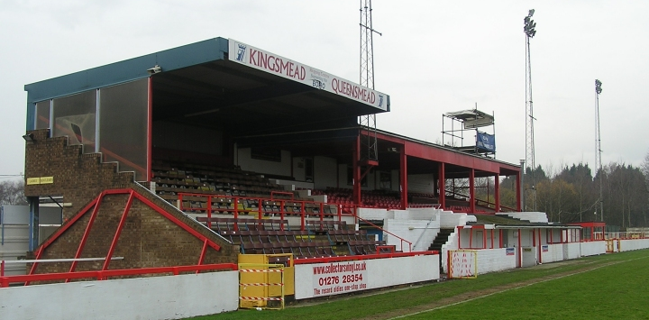
In 1982/83 we lost twice, and even in our promotion-winning season we were unable to defeat them at home, being held 2-2 after blowing a two-goal lead. Fortunately, I will never forget the return fixture on 1st May 1984 when we recovered from conceding a suspect opening goal to win 2-1 and secure promotion to the Isthmian League Premier Division with goals from Steve Milton and Murray Jones.

True to form they followed us up again the next year and in 1985/86 we met for the first time in Premier Division action. We again lost at home, and by the time of our last meeting on 8th April 1986 we were desperate for any points to avoid relegation, and came from behind to defeat them 3-2 with a superb David Jones long range strike deservedly earning the points.

Since then they have been onwards and upwards to the Third Round of the F.A.Cup where they drew with West Ham United, and reached the Conference, before collapsing back down to earth and sadly folding. Now re-branded as Farnborough F.C. they are gambling a bit by developing Cherrywood Road (which is now known as the Rushmoor Stadium) on a massive scale, and sit in the Blue Square Conference South. We have visited the ground twice in recent years when we met Badshot Lea, who were ground sharing there at the time before decamping to Godalming, winning one and losing one of the two incident packed games.
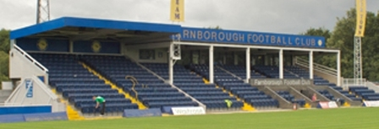
Farnborough’s main stand before and after refurbishment

Alan Carter
Mystic Al’s top 10 January
“Transfer Window” predictions

Those of you who regularly read my programme column know that I’m obsessed with lists. I regularly compile “Top 10’s” for various football, and some times non-football related subjects, some of which have been published in this very programme.

However, not many of you will know that I’m actually a trained fortune teller. OK, so that’s not strictly true but go with it for the purposes of this article. With the January transfer window now open, I’ve come up with a list of my top 10 predictions, so in February we’ll see if I can really claim to be “Mystic Al”.


CARLOS TEVEZ (aged 27, forward) Manchester City

The Argentine is on his way out and both Milan clubs are reportedly interested. However, City are currently holding out for a permanent deal. Will this be a deal breaker?

Mystic Al’s prediction: AC Milan (initially on loan and joining them permanently in the summer)

JUNIOR HOILETT (21, winger), Blackburn Rovers

One of Blackburn Rovers few top performers this season, Hoilett is out of contract in the summer and Blackburn’s Indian owners could well cash in on him. Newcastle, Spurs and Liverpool are apparently interested, but I think Tony Pullis at Stoke may persuade him to join his charges.

Mystic Al’s prediction: Stoke City

WAYNE BRIDGE (31, left-back) Manchester City


Pocketing a reported £90k-a-week but not in manager Roberto Mancini's plans, the former England International looks certain to leave.


Mystic Al’s prediction: Arsenal (assuming Bridge is willing to take a significant pay cut)

JAMES TOMKINS (22, centre-back), West Ham United

The “Hammers” talented England Under-21 central defender has been targeted by Newcastle. West Ham owner David Gold insists they won’t sell, so I expect him to join the Toon Army late in the transfer window.

Mystic Al’s prediction: Newcastle United


CHRIS SAMBA (27, centre-back) Blackburn Rovers

Unhappy at the club and has made that clear. A big asking price may put off any potential suitors from making a bid. He could join Newcastle but if the Toon Army manage to sign James Tomkins (below) I expect Samba to join Spurs on deadline day.

Mystic Al’s prediction: Tottenham Hotspur

FLORENT MALOUDA (31, winger) Chelsea

The Frenchman has been forced out of the Chelsea First team since Juan Mata's arrival at Stamford Bridge. My money is on him returning to France and joining ex-Blues boss Carlo Ancelotti at Paris Saint-Germain.

Mystic Al’s prediction: PSG

NICKY MAYNARD (25, forward) Bristol City

After refusing to sign a new contract, Maynard has been told he can leave Ashton Gate. With the futures of current Fulham strikers Andy Johnson and Bobby Zamora up in the air, don’t be surprised if he joins Martin Jol’s men this month.

Mystic Al’s prediction: Fulham

KAKA (29, forward) Real Madrid

The Spanish giants are keen to offload a player earning £8.5m - plus per year. Paris Saint-Germain and Chelsea are reported to be interested but I expect Chelsea to nab him for circa £20 million on transfer deadline day.

Mystic Al’s prediction: Chelsea

DANIELE DE ROSSI (28, midfielder) Roma

His contract expires in the summer and he has not yet signed a new deal. Manchester City have repeatedly denied an interest in the Italian, so put your money on him turning up at the City of Manchester stadium.

Mystic Al’s prediction: Manchester City

RICCARDO MONTOLIVO (26, midfielder) Fiorentina


The Italian looks likely to move away from the Viola. With Lucas out for the season and Stephen Gerrard injury prone and “knocking on a bit”, don’t be surprised if Montolivo turns up at Anfield.

Mystic Al’s prediction: Liverpool








Epsom & Ewell Football Club - History
The Club was founded in March 1918 as Epsom Juniors Cricket Club and played throughout the summer. In the autumn, Epsom Juniors F.C. came into being and they played a handful of games from what is now known as Alexandra Recreation Ground. Competitive football followed as the club entered the Surrey Junior League in 1919, and then became founder members of the Sutton & District League in 1920.

A change of name in July 1922 to Epsom Town F.C. heralded the start of a very successful era. By now resident at the Horton Hospital Sports Ground, they were unfortunate to lose 2-1 after extra time at Dorking F.C.’s Pixham Lane ground to Caterham Mental Hospital in a replay of the Surrey Junior Cup Final. However, they won three other trophies that season, the Leatherhead Hospital Shield, the Sutton Hospital Cup, and the Epsom Hospital Cup. In addition, the Club also won the Sutton & District League, and under the forward thinking of their Chairman Hugh Bradley, they took the step into Intermediate Football, where they won the Southern Suburban League without losing a match. Senior football was granted the next season, as they were unanimously accepted into the Surrey Senior League for 1924/25, where they finished third.

In September 1925, the club relocated to the old Ewell F.C. ground at West Street, which was purchased through the generosity of the Club’s future President Robert Bradshaw. In 1925/26 the Championship of the Surrey Senior League was attained, and the following season, they did the “double”, defeating Egham 1-0 at Egham in the League Charity Cup. Election to the London League was next, and the title was claimed in the club’s first season there in 1927/28. Unfortunately, they were unable to repeat this, although they would finish runners-up in 31/32, 32/33, 34/35, 36/37 and 37/38. Cup Honours were limited, although they lost 3-2 to Redhill in front of 4,600 at Guildford in their first Surrey Senior Cup Final, having seen off Wimbledon 4-1 in the semi-final! Also, the club won the Surrey Charity (Senior) Shield in 1933 with an impressive 5-0 win over Woking at Kingfield. However, the proudest moment of the club’s pre-war history was an appearance in the First Round Proper of the F.A.Cup in 1933/34. Woking (after a replay), Nunhead, Tooting & Mitcham, Beddington Corner, and Leytonstone were defeated, and a crowd of 9,485 at the Lea Bridge Speedway Stadium witnessed a 4-2 loss against the hosts Clapton Orient. At the end of that season the club changed its name to Epsom F.C. while in 1936 the closure of their Reserve team enabled the newly formed Ewell and Stoneleigh to spend two years there ground sharing while in the Surrey Senior League, and local works team Venners Sports were tenants in the final completed pre-war season.

In 1939 a newly formed team, Epsom Town (no connection to the earlier team) shared the ground with Epsom F.C. However, this arrangement was suspended when war was declared, and the parent club folded for the duration. In the meantime, Club Chairman Charles Pettett threw in his lot with Epsom Town in an attempt to keep morale up in the town by keeping the football flag flying. It was successful, as the club competed throughout the war years, winning the Surrey Combination in 1939/40, and reaching the Surrey Senior Cup Final in 1944, losing 3-1 to Tooting & Mitcham, at Sandy Lane. After the war, Epsom F.C. started up again, continuing in the London League and reclaimed their ground, leaving Epsom Town homeless. Temporary homes were found at Kings College, Lavender Avenue, Mitcham, and then at the Old Halleyburians Rugby Ground in Ruxley Lane, as they competed for a season in the newly created Corinthian League, but disbanded in 1946.

In 1949 Epsom F.C. departed the London League, and entered the Corinthian League themselves, but despite a 3-2 win over two time Champions Walton & Hersham in their first home match, they would not win away in the League for nearly three years. They did reach the Corinthian Memorial Shield Final in 1952, going down 2-1 to Champions Hounslow at Eastbourne after leading at half-time. Things continued to improve with the signing of the famous ex-Amateur International Pat Lynch from Hendon. The club achieved their highest ever placing of third in 1952/53, and in 1954 reached the Surrey Senior Cup Final for the third time in their history, losing unluckily 2-0 to Corinthian Casuals in front of 6,159 at Selhurst Park, and in 1955 they won the Surrey Senior Shield with a 1-0 win over Carshalton Athletic at West Street.

There was a massive new player influx in 1955 after the club appointed their first ever manager in Kingstonian legend Doug Whitehead. The Corinthian League double was almost achieved in 1956/57, but two losses in the final week, along with defeat in the Cup Final 2-0 to Maidenhead

United at Dorking, ensured that the club got neither, only finishing fourth. However in 1960, they finally got their hands on the Shield with a 2-0 revenge win over Maidenhead at Vale Farm, home of Wembley F.C. This was the last season with the club for veteran Ernie Watkins, who had played for the club for fifteen seasons since the end of the war. He would go on to play for eight more years at Banstead Athletic before retiring in 1968 aged 47!

In 1960 the club changed its name once again to Epsom & Ewell F.C. This was not because of any merger with Ewell & Stoneleigh as is often quoted, because they had folded in 1938! It was an attempt to increase support across the whole of the Borough. In 1963 the Corinthian League merged with the Athenian and Delphian Leagues, and the club were placed in Division One of the new structure, but the sixties was full of poor results and relegation was the result in 1965. Despite a string of managers, most notably ex-Leyton Orient winger Jimmy Simth, and Tony Williams, now famous for his creation of the F.A. Yearbooks, the club’s fortunes did not improve significantly, and further relegations were avoided in the early seventies by the benefit of re-election. However in 1973, despite “improving” to finish second from bottom, the Athenian League finally ran out of patience and cut them loose. This was unfortunate timing as the club had just cleared all of its debts, and in addition to a virtually new Committee, former Fulham player Pat O’Connell took over the reins. The Surrey Senior League took the club in at the last minute, and the new squad, including young striker Tommy Tuite, won the League Cup and the following season the club achieved their second Surrey Senior League “double”. However, season 1974/75 would always be remembered for reaching the Final of the inaugural F.A. Vase, where 9,500 saw the Blues edged out 2-1 by Hoddesdon Town at Wembley Stadium. The Athenian League welcomed them back, and despite losing Trevor Lee and Phil Walker to Millwall in November 1975 promotion was achieved, and the next season the club reached the Athenian League Cup Final, losing 1-0 at Chalfont St Peter.

In season 1977/78 many clubs were invited to join the expanding Isthmian League, and Epsom & Ewell were placed in the new Division Two. Their first match under floodlights followed against Met Police, and the Championship was clinched the following April with the Police as runners-up. In 1979/80 the club won the Southern Combination Cup 7-2 at Hampton, where the hosts were blitzed by five goals from Tuite. The following season a new clubhouse opened, and the club finally won the Surrey Senior Cup, defeating Woking 2-1 at Tooting & Mitcham. The club just missed out on promotion to the Premier Division that season, but in 1983/84 the club clinched promotion as runners-up, although this time they were defeated in the Surrey Senior Cup Final, 4-0 by Sutton United at Imber Court.

With Adrian Hill as manager since 1982, the club survived comfortably in its first season at the new level, but Hill’s departure to Croydon in 1985 started a decline. Much of the squad also left with Hill, and new manager Alan Webb had too much to do. The club was relegated, and following Webb’s departure in 1986, player manager Ricky Kidd nearly but not quite saved the club from its second straight relegation. Adrian Hill replaced Ricky Kidd for a second spell at the helm in 1990, but the club were placed in the new Division Three in 1991 after league reorganisation.

In 1993 the club left West Street and moved in as tenants of Banstead Athletic and the decade was largely one of frustration, although the Final of the Associate Members Trophy was reached, where Bedford Town edged them out 2-0 at Hendon’s old Claremont Road ground.

In 2002 Adrian Hill took the Blues back up to Division 1 South, where they topped the table for a month, eventually finishing 9th, but Hill’s retirement at the end of the season led to relegation the following season, Two seasons in Division 2 followed before it was disbanded in the latest F.A. reorganisation, and they now compete in the Combined Counties League Premier Division under the guidance of manager Lyndon Buckwell, a former player at the club. Lyndon has been here since October 2006, and his first full season (2007/08) resulted in our first top ten finish since 2003. In 2008/09 the team exceeded this achievement and finished in fourth place after heading the table for the first few months of the season. In 2009/10 the club recovered from a slow start to finish fifth and also reached the last 32 of the F.A.Vase for the first time in 21 years, bowing out 3-2 in Northamptonshire to Long Buckby. In April of 2010 the club terminated their seventeen-year ground sharing agreement with Banstead Athletic and are now in their second season at Merstham F.C. Meanwhile, the search continues for a new ground back in the Borough………

Matches against Wembley F.C.
As advised earlier in the programme, this is the fiftieth meeting between the clubs, so I thought I’d do a little summary.

The clubs nearly met in 1939. This might seem a little odd, seeing as they were founded in 1946. However, my records quite clearly show a new club called Wembley F.C. joining Epsom in the London League for that ill-fated 1939/40 season. Whether the two clubs had any connection, only Wembley people could really know.

Still, they never met as the season lasted just two weeks before the declaration of World War Two.

Wembley joined us in the Corinthian League in 1956 and we finally met for the first time on the 9th February 1957, recording the first of our 14 draws with an entertaining 3-3 encounter at West Street (see programme right) In fact, draws are something these meetings have provided quite frequently. Only Camberley have drawn more matches against us with twenty, but we have met them on 76 occasions!

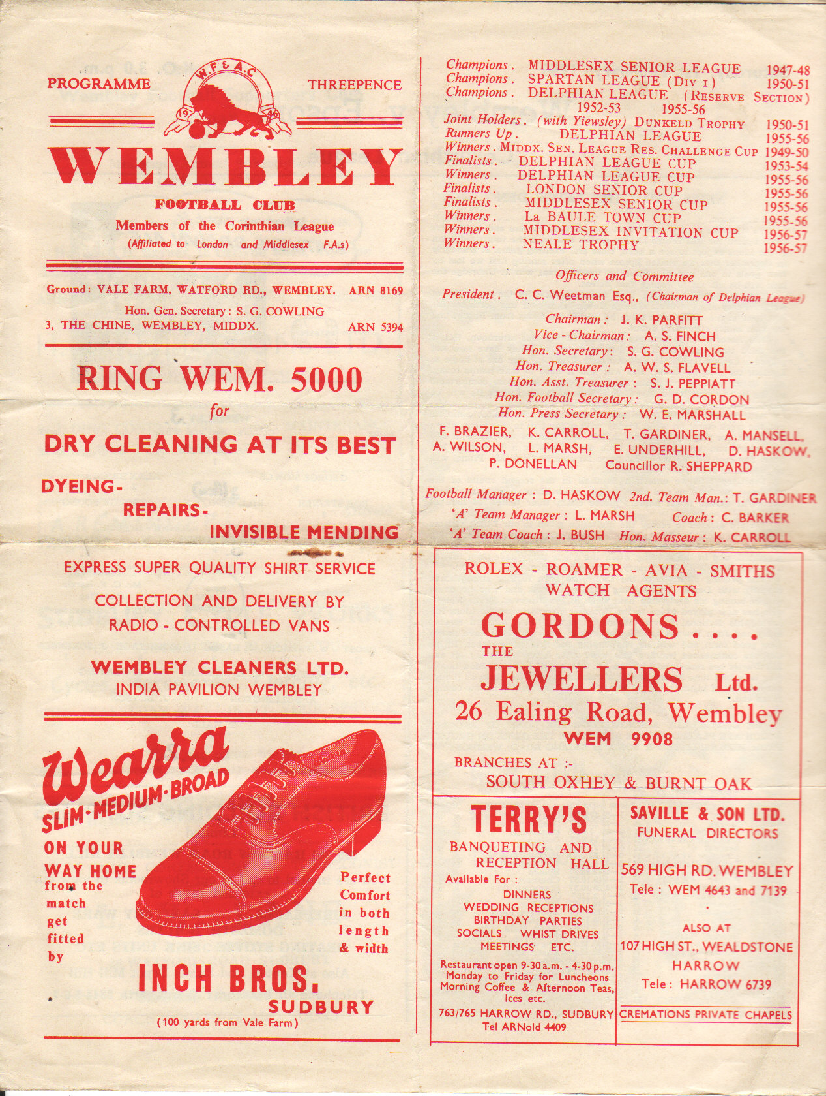
Johnny Bangs scored twice while Brian Jenkins got the other from the penalty spot as the Blues fought back from three goals down to get the point, and we scored three again in the return in a Wednesday evening match on 17th April 1957 through Ray Colfar, Dave Hermitage and Bangs again, winning 3-0 on our first visit to Vale Farm.

Our next meeting on 7th December 1957 was notable for a hat trick from Jan Sorensen, whose sons Erik and Mick would later play for us. We won 4-1 that day with Bily French scoring the other goal, but despite two more goals from Bangs, we slipped to a 3-2 defeat in the return at Wembley on 1st February 1958 (see programme left).

We had our first ever goalless draw with Wembley the following January, which broke a run of eight straight home wins for the Lions, but we then lost for the first time at West Street on 4th April 1959 by two

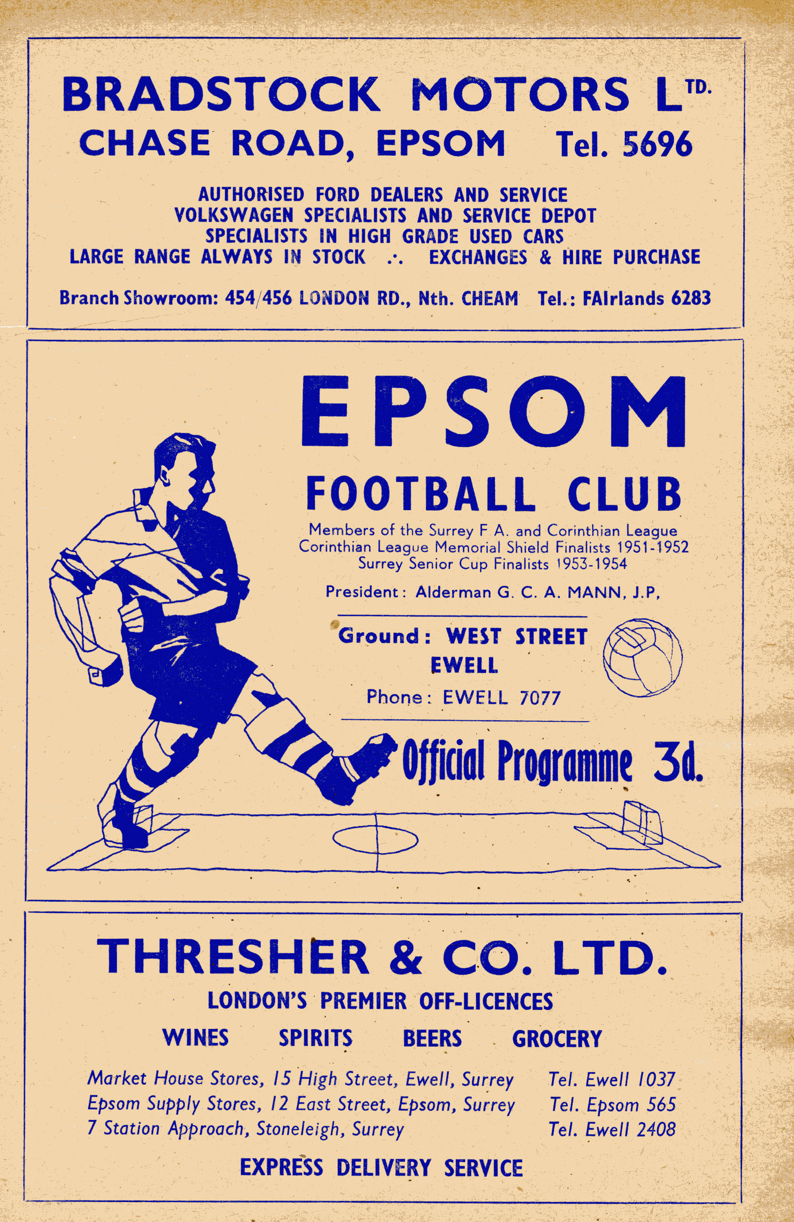

goals to one, with Tommy Millard scoring our goal.

In 1959/60 we started our season poorly, but by the end we were flying, and we caught our opponents twice at the end of that season, although we had to fight back from two goals down in the first of these, a 3-2 win at West Street, requiring two goals from Norman Dearlove, and a goal from Ray Francis which made up for his penalty miss.

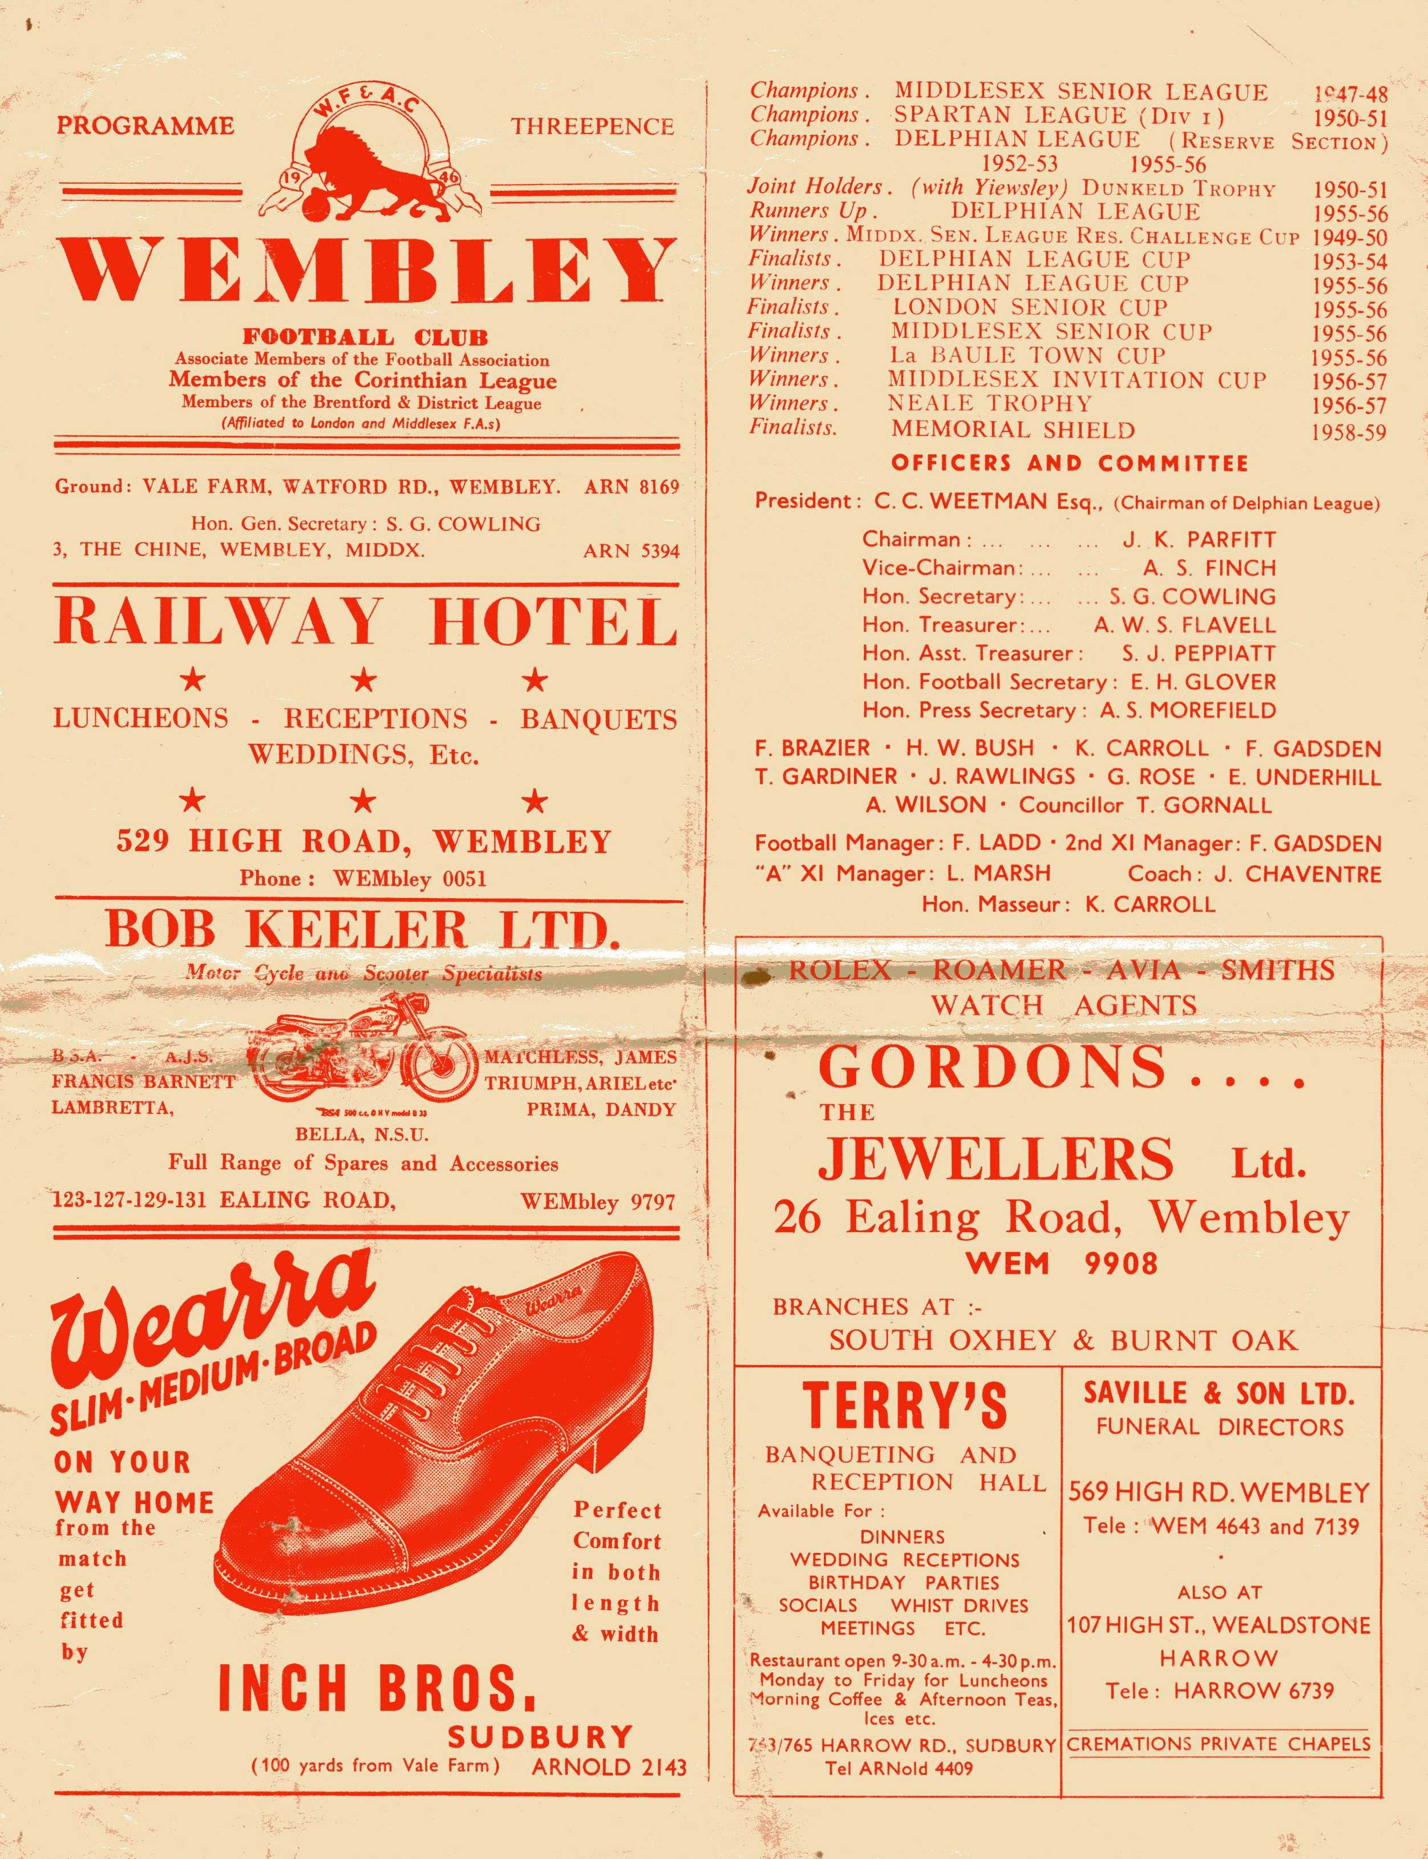
The return resulted in a comfortable 3-0 win at Vale Farm on 23rd April 1960, which was ideal preparation for our boys as they visited Vale Farm just seven days later for the Corinthian League Memorial Shield Final, defeating Maidenhead United 2-0 with Steve Dunwoody returning from National Service to score both goals. Ironically, we never met Wembley in that competition, despite it being only a sixteen-team league. (see programme above)

Unfortunately, that Shield win was a high water mark for the club that would not be surpassed for fifteen years and the sixties were a bad time to be an Epsom supporter. Almost from the point that the name of the club changed to Epsom & Ewell FC from Epsom F.C. our fortunes started to change.

In fairness Wembley suffered at this time too, and in the early sixties we regularly met in basement battles. In 1961/62 and 1962/63 they were the only club to finish above us, and for the next two seasons we were bottom, while the Lions reached the dizzy heights of tenth out of fourteen and fourteenth out of sixteen.

The 1962/63 season was notable for bad weather, but it was also the first time that either of the clubs recorded a League double. The more important of the two results was our 6-1 win on 15th May 1963. Had we lost the match, we would have been at the foot of the table instead but a hat trick from Barry Sargent helped us to a 6-0 lead after 78 minutes and finished off as 6-1 winners. Another goal that day came from Larry Pritchard who would go on to make nearly fifty Amateur International appearances for England.

However, the more significant of the results as it turned out was our 2-0 win at Vale Farm on 6th October 1962. Two second half goals from Australian player Taz Arnall ensured a win that would prove to be our last at Vale Farm for an astonishing 46 years and fourteen visits.

In 1963 the Corinthian League merged with the Athenian and Delphian Leagues and on 7th December 1963 goals from Bill Mackay, Norman Derry and Keith Williams gave us a 3-2 win which were the first points we had earned all season following 11

straight defeats. A month later though we suffered a 4-1 defeat there, despite being level at half time.

A Bill Mackay missed penalty proved costly as we could only draw 1-1 at Vale Farm the following season, but in our last Athenian League match on 16th January 1965 Mackay scored and an own goal gave us the points in a 2-1 win at West Street. (see programme left)

The reason it was our last Athenian League match was because our foot of the table position gave us the first relegation in our history and we would not meet again until 1978/79. As regular readers know things went from bad to worse in the late sixties and early seventies but the resurgence under Pat O’Connell gave us new life and the Championship of the Isthmian League Division Two earned us a promotion to Division One and regular meetings recommenced.

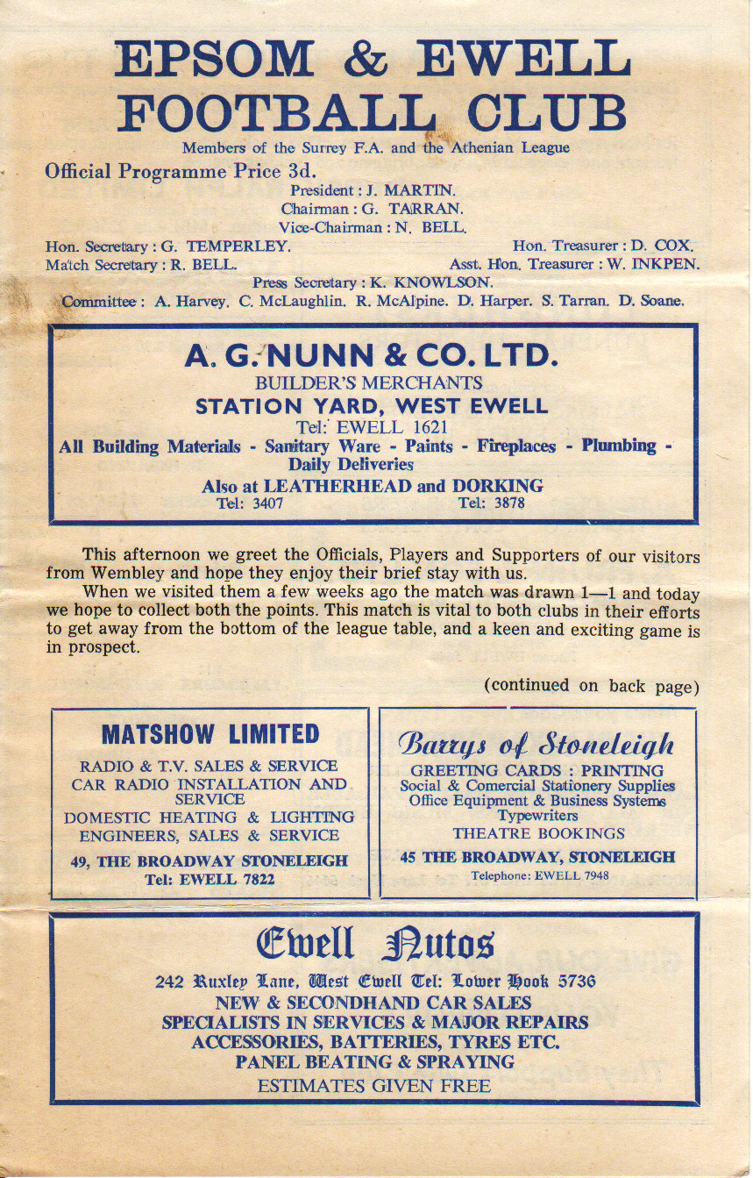
Although my early memories are of regular meetings with Wembley this was a particularly dull sequence of matches. We met on fourteen occasions and nine of them were draws. Additionally, only four of these games ended with either team scoring more than once. Four were goalless and five finished 1-1.

Matches were still memorable, but not all for football reasons. On 27th February 1982 we lost 1-0 in a match that proved pivotal in our history as Pat O’Connell and most of the playing staff departed shortly after this game. (see programme right) I also recall a very cold Tuesday evening in December 1982 when just 27 paid to watch us get a 1-1 draw with a late Steve Hill equaliser. I shouldn’t have been there at all as I was off school all week with one of just three bouts of flu that I have had in my lifetime and shivered through the match. I also recall a Colin Miles penalty that put us ahead in April 1984, and although we conceded an equaliser late on, we knew we were now favourites to take the second promotion spot behind Windsor & Eton, which we secured a couple of weeks later.

Another memory I have was from 1986/87. We led 2-1 thanks to goals from player manager Ricky Kidd, and a fantastic thumping header from Mark Norman, his only goal for the club. Wembley
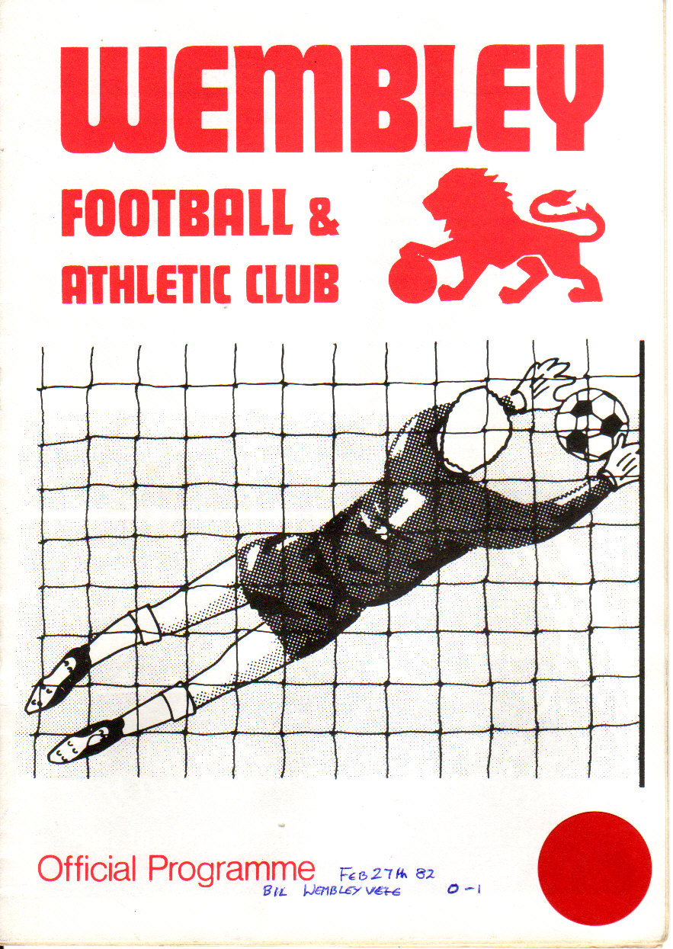

fought back to lead 3-2 by half time, but Norman had clearly wound up their striker Peter Shoedinde, who pushed the referee out of the way to punch him! Regrettably despite the player advantage for the whole second period, we were unable to secure anything from this game and went down by a point that year. (see programme right)

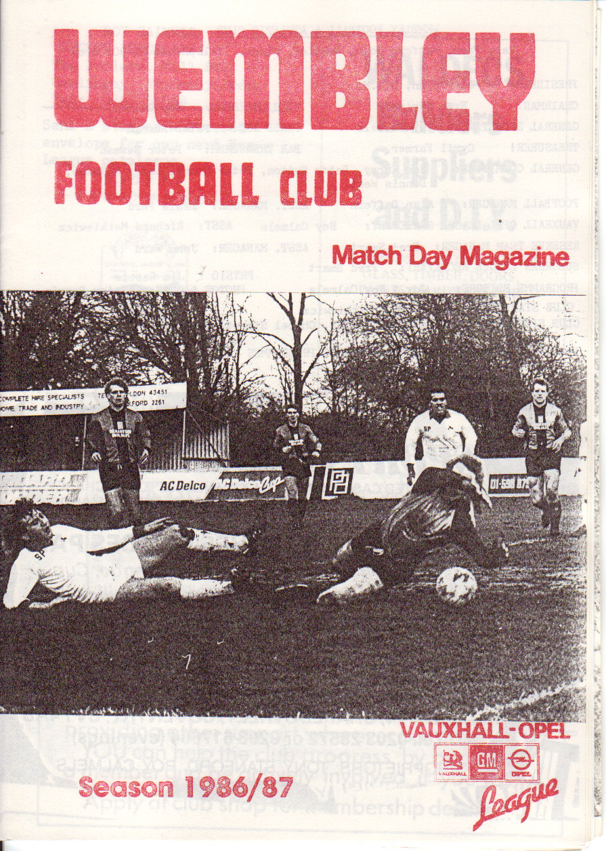
And with exception of a no-contest F.A.Cup tie at Merland Rise in 1994 when Wembley were two divisions above us and won 3-1 that was it until 2004/05. Our opponents had been in Division One for so many years without going up or down, while we had spent a lot of time in the lower reaches of the Isthmian League before our promotion in 2002, which then became relegation two years later. So of all the teams to meet it was a surprise to find them in the rump Division Two, the unwanted bit of the Isthmian League, which was eventually cut off in 2006 when both clubs transferred into the Combined Counties League.

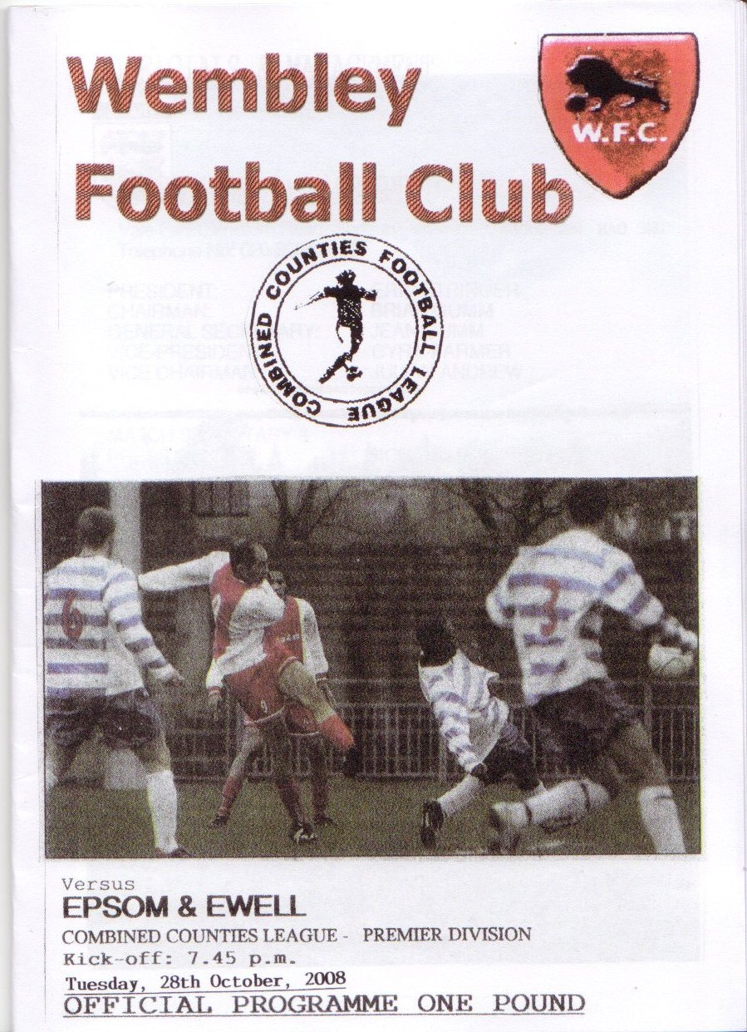
For the first few meetings Wembley held sway before we started to get some good wins, and my favourite memory occurred on Tuesday 28th October 2008. (see programme left) The snow was falling on a perfect playing surface while the skies were alight with fireworks from all around the ground as the Festival of Diwali was celebrated. On the field we celebrated our first win at Vale Farm since 1962, and actually led 4-0 at half time with a couple each from Robbie Burns and Kyle Hough, while Dale Marvell got the other one. Hough’s goal from a keeper error sticks in my mind as it was kicked straight to him and he belted it straight back in to the net at the far end of the ground from distance!

It was a wonderful atmospheric evening at a ground that I consider one of my favourites. With the impending Step Five reorganisation planned for the end of 2012/13, we may only have one more visit there to come. Get along if you can.

Player Sponsorship
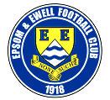 |     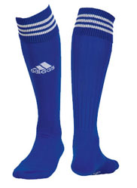  Please Sponsor one of our players for £40.00.  Just speak to any Committee Member.
Nathan Ayling | Peter Coles
Ramzi Bedj Bedj | Steve Davies & Gary Ellis
Robbie Burns | Pizza2Go –  716 London Road, North Cheam 0208 6442211
Dan Coles | Joe Hagan P.G.A. Golf Pro – 07973 264151
Jamie Cottee
Ali Dewar | ID & JD Services
Carl Downs | Mike and Janette Summers
Aaron France
Dave Francis | Paul Marshall & Dougie Burns
Jamie Hatfield | Pete Lumm
Ben Hayward | Geoff Dyke
Mark Jarman | Up and Out Lofts Ltd

Adrian Jones
Alex McGregor | John Bonner
Alex McKay
James Moon
Antony “Freddie” Myers | Tony Jeffcoate
Anthony Panayi | The Boys behind the goal
Ayden Richards
Sam Robinson | Geoff and Arnold Pye
Alex Rodrigues | Pete Beddoe
Tom Siefers
Matt Smith | The Jarman Family
Jamie Summers | Dave Ellins
Paul West | Someone Has To Ltd!
Ross White
Lyndon Buckwell | Darryl Hatfield
Tony Coombe
Glynn Mandeville | Mark Jarman
Ken Jones
Tony Knight | Paul West

This Season’s Match Sponsors
Fixture | Date | Match Sponsor | Ball Sponsor
Colliers Wood United | 09/08/11 | Epsom & Ewell F.C.  Management Committee
Windsor | 13/08/11 | Richard Lambert
Croydon | 21/08/11 | Joe Hagan P.G.A. Golf Pro – 07973 264151
Guildford City | 23/08/11 | Steve Dyke
Mole Valley SCR | 27/08/11 | Tony Jeffcoate
Chipstead | 04/09/11 | Pete Beddoe | Paul Merritt
Hanworth Villa | 08/10/11 | Joe Hagan P.G.A. Golf Pro – 07973 264151
Horley Town | 25/10/11 |  | Pete Beddoe
Badshot Lea | 29/10/11 | Geoff Dyke
South Park | 12/11/11 | Gemma and Kirsty Herbert
Croydon | 19/11/11 | Mid-Surrey Mencap | Dave and Nicola Beddoe
Egham Town | 03/12/11
Sutton United | 06/12/11 | In memory of Chris Henry
Cove | 17/12/11
Wembley | 14/01/12
Dorking | 28/01/12
Molesey | 31/01/12
Farnham Town | 11/02/12
Sandhurst Town | 25/02/12
Ash United | 17/03/12
Chessington & Hook | 31/03/12
Banstead Athletic | 09/04/12 | Tony Foster
Camberley Town | 21/04/12
Raynes Park Vale | tba | Amit Badami
For League Matches:
Match sponsorship is available for £35.00.

Match ball sponsorship is available for £20.00.

For Cup Matches:
Match sponsorship is available for £45.00.

Match ball sponsorship is available for £25.00.

Match sponsorship includes admission, programmes, advertising
and hospitality for two.

Match ball sponsorship is the same as above but just for one.

Interested? Please speak to a Committee Member now!

Steve Davies
Highs and Lows

If I was to chart on a graph my emotions from 38 years of watching football the outcome would look like one of those Life Support machine screens that you see in many movies placed next to a critical hospital patient making a “ping” sound every few seconds.


Last Saturday, after losing 4-1 in the Combined Counties league Cup to Step Six Worcester Park the chart hit it’s lowest ever point. I do believe that in all my years of watching Epsom that was the performance that most disappointed me. (This honour had previously been awarded to our F.A. Vase exit at Chichester a few seasons ago.)

To cheer myself up I decided to visit the Abbey Stadium on Tuesday night to see Cambridge United take on Grimsby Town in the Blue Square Conference. I purchased a Cambridge Scarf and paid my £14 to stand in the North Terrace amongst the home faithful. There was a decent crowd of 2,840 that included a loyal following from Grimsby of around 450 fans. One United fan possessed a very large drum which he started beating enthusiastically supported by the majority of the North Terrace loudly chanting “Yellow and Black Army” which went on for about 80% of the 90 minutes of play.

Cambridge were disappointing, Grimsby looked very impressive which was no surprise as they had only lost one of their previous 15 games which included a 7-0 thrashing of Stockport County. A very strange incident occurred after 15 minutes as a poor back pass let in a Grimsby forward but the advancing keeper blocked the shot with his legs. I had an excellent view of this as the incident occurred at our end of the ground and it was with incredulity that I heard the referee’s whistle blowing for a penalty especially as he was only a few yards from the incident and must have had an excellent view. Naisbitt, the Cambridge keeper was naturally incensed and so were the home defenders who all remonstrated with the referee and persuaded him to consult with his linesman.

After this consultation he amazingly reversed his decision, awarding a drop ball on the penalty spot that was hoofed away by the United centre half after Grimsby protestations at the decision reversal were waved away. The Mariners were appeased ten minutes later as Grimsby scored the only goal of the game to inflict only Cambridge’s second home defeat of the season. (My theory that I am a curse when I attend games is gaining strength every week, (I haven’t seen an Epsom win since Hailsham).

Reading the excellent programme I was interested to see an article written

by a United fan which described his lowest ever Cambridge moment. He described a home match against Kidderminster in early 2005 where both teams were sitting in the bottom two places in League Two.

As the teams immediately above them were starting to pull away, whoever lost this match would be looking doomed. Cambridge took an early lead but then had a man sent off and soon they were losing 3-1. The fan described how he was standing in the North terrace stunned and silent and said that it felt like attending the funeral of a loved one.

Then, another home supporter started a” Yellow and Black Army” chant but the rest of the fans told him to shut up. He ignored the advice and persisted with the chant for the next fifteen minutes until his voice started to go hoarse. The lone voice eventually became exhausted and stopped. Spontaneously the whole terrace started up a chorus of “You’re not singing any more”! That marked the end of Cambridge United’s league existence and was the writer’s all time football low.

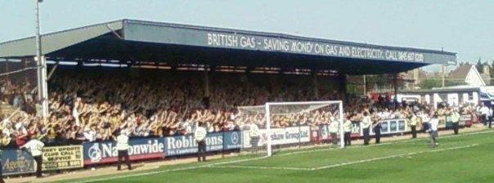
The North terrace at the R. Costings Abbey Stadium.

An interesting fact also emerged from the programme. In 1989 Grimsby, Cambridge Utd and Southend were promoted from Football League Division 4 to Division 3. The very next season ALL three clubs were promoted again, gaining a place in Division 2.

Finally, let’s forget about Worcester Park and look back on my Number One Epsom & Ewell High. It must have been the final whistle blowing at Stamford where Epsom held the United Counties League side to a goalless draw to book a place in the 1975 F.A. Vase Final. After winning the first leg 2-1 at West Street we made the long trip to Lincolnshire where every minute of the game seemed like an hour, as we only needed a draw to get to Wembley Stadium.

Epsom defender Willie Bennett was so nervous that he threw up in the dressing room before the game! When the final whistle blew with the score at 0-0 I went into delirium mode!

Club Directory
ASH UNITED Telephone: 01252-320385 - Ground: Shawfields Stadium, Youngs Drive, Shawfields Road, Ash, Aldershot, Hants. GU12 6RE - Colours: Green/Green/Green

BADSHOT LEA Telephone: 01483-417520 - Ground: Godalming Town FC Weycourt, Meadrow, Farncombe, Godalming, Surrey. GU7 3JE - Colours: Claret/White/Claret

BANSTEAD ATHLETIC Telephone: 01737-350982 - Ground: Banstead Athletic, Merland Rise, Tadworth, Surrey. KT20 5JG - Colours: Amber &Black/Black/Black

CAMBERLEY TOWN Telephone: 01276-65392 - Ground: Krooner Park, Wilton Road, Camberley, Surrey. GU15 2QW - Colours: Red & White Stripes/Red & Blue/Red

CHESSINGTON & HOOK UNITED Telephone: 01372-745777 - Ground: Chalky Lane, Chessington, Surrey. KT9 2NF - Colours: Blue/Blue/Blue

COLLIERS WOOD UNITED Telephone: 0208-942-8062 - Ground: Wibbandune Sports Ground, Lincoln Green, Opposite 199-213, Robin Hood Way, Wimbledon. SW20 0AA - Colours: Blue &Black/Black/Black

COVE Telephone: 01252-543615 - Ground: Oak Farm Fields, Squirrels Lane, Cove, Farnborough, Hampshire. GU14 8PB - Colours: Yellow/Black/Yellow

CROYDON Telephone: 0208-654-8555 - Ground: Croydon Sports Arena, Albert Road, South Norwood, Surrey. SE25 4QL - Colours: Sky Blue/Sky Blue / Sky Blue

DORKING Telephone: 01306-881102 - Ground: Meadowbank, Mill Lane, Dorking, Surrey. RH4 1DX - Colours: Green & White Hoops/Green & White/Green

EGHAM TOWN Telephone: 01784-435226 - Ground: The Runnymede Stadium, Wards Place, Egham, Surrey. TW20 8XD - Colours: Red/Red/Red

EPSOM & EWELL Telephone: 01737-644046 - Ground: Merstham FC, Weldon Way, Merstham, Surrey. RH1 3QB - Colours: Royal Blue & White Hoops/Royal Blue/Royal Blue & White Hoops

FARNHAM TOWN Telephone: 01252-715305 Ground: Memorial Ground, Babbs Mead, West Street, Farnham, Surrey. GU9 7DY Colours: - Claret & Sky Blue/White/Claret & Sky Blue

GUILDFORD CITY Telephone: 01483-443322 - Ground: Spectrum Arena, Spectrum Leisure Centre, Parkway, Guildford, Surrey. GU1 1UP - Colours: Red & White Stripes/Red/Red

HANWORTH VILLA Telephone: 0208-831-9391 - Ground: Rectory Meadows, Park Road, off Hounslow Road, Hanworth, Middlesex. TW13 6PN - Colours: Red & White/Black/Black

HORLEY TOWN Telephone: 01293-822000 - Ground: The New Defence, Court Lodge Road, Horley, Surrey. RH6 8RS - Colours: Claret & Sky Blue/Claret/Claret

MOLE VALLEY SCR Telephone: 01932-866386 - Ground: Cobham F.C. Leg O'Mutton Field, Anvil Lane, Downside Bridge Road, Cobham, Surrey. KT11 3SY - Colours: Red/Red/Red

MOLESEY Telephone: 0208-979-4283 - Ground:412 Walton Road, West Molesey, Surrey KT8 0JG - Colours: White/Black/Black

RAYNES PARK VALE Telephone: 020-8540-8843 - Ground: Prince Georges Playing Field, Grand Drive, Raynes Park, London. SW20 9NB - Colours: Yellow/Red/Yellow

SANDHURST TOWN Telephone: 01252-878768 - Ground: Bottom Meadow, Memorial Park, Yorktown Road, Sandhurst, Berks. GU47 9BJ - Colours: Red/Black/Black

SOUTH PARK Telephone: 01737-245963 - Ground: King George's Field, Whitehall Lane, South Park, Reigate, Surrey. RH2 8LG - Colours: Red/Red/Red

WEMBLEY Telephone: 0208-904-8169 - Ground: Vale Farm, Watford Road, Sudbury, Wembley. Middlesex. HA0 3AG - Colours: Red & White/Red/Red

WINDSOR Telephone: 01753-860656 - Ground: Stag Meadow, St Leonards Road, Windsor, Berks SL4 3DR - Colours: Red & Green, Red & Green, Red

Where to Next?
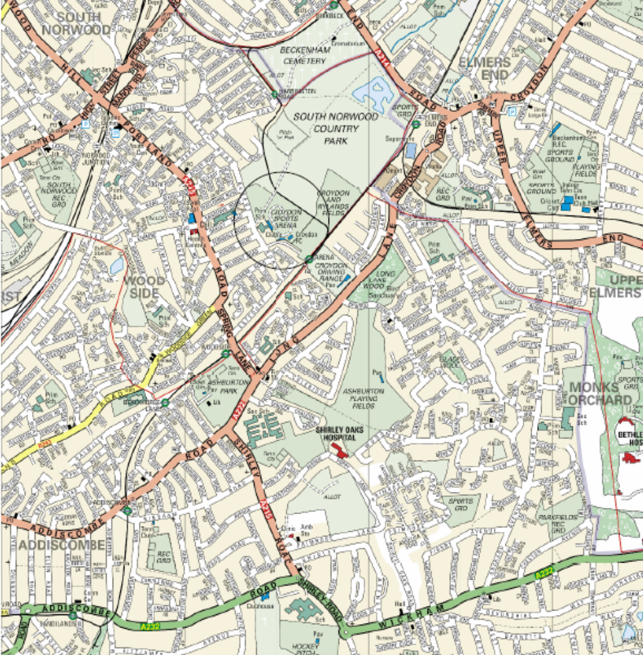

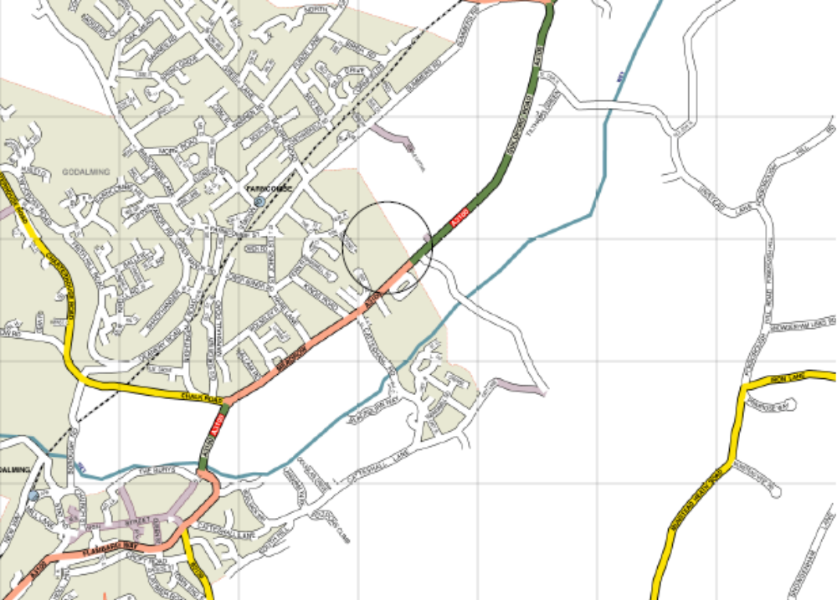
Croydon – Saturday 21st January

Badshot Lea – Saturday 4th February

Supporters Player of the Match
Each week one of our players wins a bonus by being named as the Supporters Player of the Match.

Our latest winner from the Worcester Park match was Antony Myers (left) and in the Banstead match the award went to our keeper Adrian Jones. (right) The awards so far are as follows:

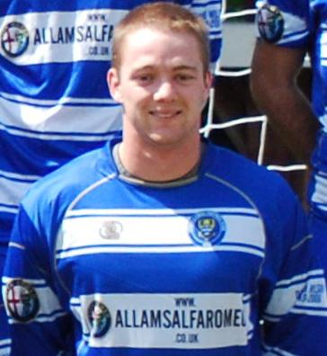
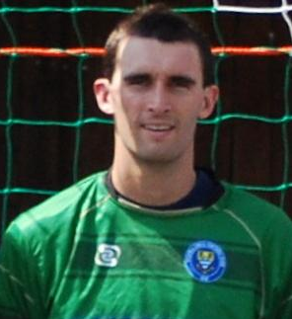

09/08/11 | H | Colliers Wood Utd | CCL | 3-1 | Chris Woodward
13/08/11 | H | Windsor | CCL | 2-2 | Dave Francis
16/08/11 | A | Farnham Town | CCL | 0-0 | Alex Rodrigues
21/08/11 | H | Croydon | FAC | 3-1 | Matt Smith
23/08/11 | H | Guildford City | CCL | 2-3 | Alex McGregor
27/08/11 | H | Mole Valley SCR | CCL | 3-1 | Antony Myers
29/08/11 | A | Raynes Park Vale | CCL | 2-3 | Jamie Summers
04/09/11 | H | Chipstead | FAC | 1-2 | Jamie Summers
10/09/11 | A | Hailsham Town | FAV | 3-1 | Robbie Burns
17/09/11 | A | Sandhurst Town | CCL | 1-3 | Robbie Burns
24/09/11 | A | Ringmer | FAV | 0-2 | Dan Coles
September |  | Monthly Award |  |  | Dan Coles
01/10/11 | H | Molesey | CCL | 2-0 | Matt Smith
04/10/11 | A | Knaphill | CCLC | 3-2 | Dave Francis
08/10/11 | H | Hanworth Villa | CCL | 2-2 | Jamie Hatfield
11/10/11 | A | Dorking | CCL | 1-1 | Mark Jarman
15/10/11 | A | Ash United | CCL | 4-1 | Carl Downs
22/10/11 | A | Wembley | CCL | 1-4 | Mark Jarman
25/10/11 | H | Horley Town | CCL | 0-2 | Nathan Ayling
29/10/11 | H | Badshot Lea | CCL | 0-2 | Ali Dewar
October |  | Monthly Award |  |  | Jamie Hatfield
05/11/11 | A | Camberley Town | CCL | 0-4 | Jamie Summers
12/11/11 | H | South Park | CCL | 3-1 | Sam Robinson
19/11/11 | H | Croydon | CCL | 2-1 | Mark Jarman
26/11/11 | A | Windsor | CCL | 0-1 | Dan Coles
November |  | Monthly Award |  |  | Sam Robinson
03/12/11 | H | Egham Town | CCL | 1-4 | Dan Coles
06/12/11 | H | Sutton United | SSC | 0-1 | Adrian Jones
10/12/11 | A | Chessington & Hook Utd | CCL | 5-5 | Sam Robinson
17/12/11 | H | Cove | CCL | 2-3 | Jamie Cottee
27/12/11 | A | Banstead Athletic | CCL | 1-0 | Adrian Jones
December |  | Monthly Award |  |  | ??
07/01/12 | A | Worcester Park | CCLC | 1-4 | Antony Myers
14/01/12 | H | Wembley | CCL

Photo of the Week
This week here is a photo from the Worcester Park game showing the supporters behind the goal in typical jovial mood! Well, this is about as good as it got on Saturday!
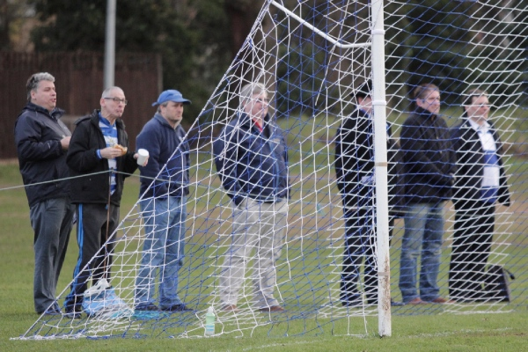
From left to right: Steve Dyke, Geoff Dyke, Richard Lambert, Steve Davies, Evan Gregory, Paul Marshall, Nigel Pond
Between them they have clocked up approximately 230 years of service!

Many more of Gemma’s photos from almost every game are available on our website: Why not have a look?
http://www.pitchero.com/clubs/epsomandewellfc/

Alan Carter’s Quiz Answers – Quiz 14
1. Ray Wilson and George Cohen.
2. Tranmere Rovers.
3. Enfield
4. Exeter City or Crewe Alexandra.
5. They have all been retired. West Ham for Bobby Moore, City for Marc-Vivien Foe and Chelsea for Gianfranco Zola.
6. Chile.
7. The theme tune of Match of the Day.
8. 52.
9. Sandhurst Town.

Combined Counties League – Premier Division
Saturday, 14th January 2012 - Kick-off 3.00 p.m.
Epsom and Ewell F.C.  (Royal Blue & White hoops) | V |  | Wembley F.C.  (All Red)
 | NUMBERS
Adrian Jones |  |  | Lee Pearce
Paul West |  |  | Kristian Hale
Jamie Hatfield |  |  | Toby Webb
(capt) Alex Rodrigues |  |  | Conor Carroll
Jamie Summers |  |  | Chris Korten
Carl Downs |  |  | Roy Byron
Matt Smith |  |  | Ian Bates (capt)
Sam Robinson |  |  | Adrian Dinham
Mark Jarman |  |  | Dean Linton
Ross White |  |  | Daryl Atkins
Alex McGregor |  |  | Bryan Marshe
Jamie Cottee |  |  | Alex Low
Ali Dewar |  |  | Alex Mokeni
Anthony Panayi |  |  | Taiwo Edun
Tom Siefers |  |  | Daniel Hailstones-Hopkins
Antony Myers |  |  | Mitchell Pont
Dave Francis
James Moon
Nathan Ayling
Alex McKay
Lyndon Buckwell | MANAGER |  | Ian Bates
Glynn Mandeville /  Tony Coombe | ASSISTANT |  | George Green
Tony Knight | COACH |  | Gary McCabe
Ken Jones | PHYSIO |  | Chris Blake
REFEREE: N.Diamini (Aldershot)
ASSISTANTS: P.Brooks (Forest Hill), P.Maskell (Epsom)

OUR NEXT FIRST TEAM MATCH AT THE MOATSIDE
Epsom & Ewell F.C.
v
Raynes Park Vale

Combined Counties League – Premier Division
Tuesday, 17th January 2012 – 7.45 p.m.

